# Page 1

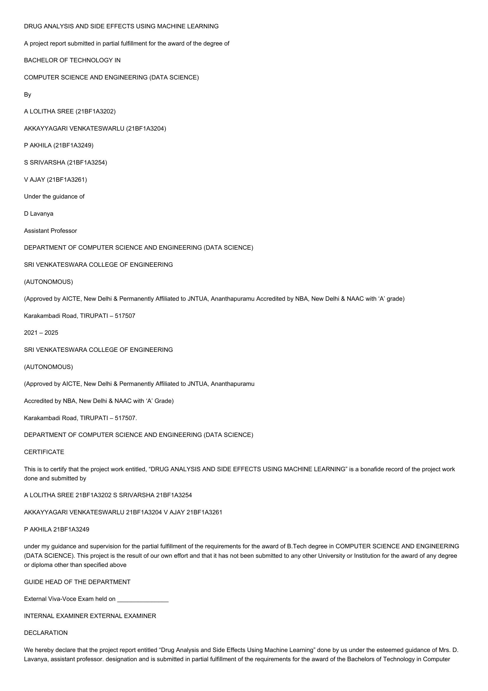

DRUG ANALYSIS AND SIDE EFFECTS USING MACHINE LEARNING  
  
A project report submitted in partial fulfillment for the award of the degree of  
BACHELOR OF TECHNOLOGY IN  
  
COMPUTER SCIENCE AND ENGINEERING (DATA SCIENCE)  
  
By  
  
A LOLITHA SREE (21BF1A3202)  
  
AKKAYYAGARI VENKATESWARLU (21BF1A3204)  
  
P AKHILA (21BF1A3249)  
  
S SRIVARSHA (21BF1A3254)  
  
V AJAY (21BF1A3261)  
  
Under the guidance of  
  
D Lavanya  
  
Assistant Professor  
  
DEPARTMENT OF COMPUTER SCIENCE AND ENGINEERING (DATA SCIENCE)  
SRI VENKATESWARA COLLEGE OF ENGINEERING  
  
(AUTONOMOUS)  
  
(Approved by AICTE, New Delhi & Permanently Affiliated to JNTUA, Ananthapuramu Accredited by NBA, New Delhi & NAAC with ‘A’ grade)  
Karakambadi Road, TIRUPATI — 517507  
  
2021 — 2025  
  
SRI VENKATESWARA COLLEGE OF ENGINEERING  
  
(AUTONOMOUS)  
  
(Approved by AICTE, New Delhi & Permanently Affiliated to JNTUA, Ananthapuramu  
Accredited by NBA, New Delhi & NAAC with ‘A’ Grade)  
  
Karakambadi Road, TIRUPATI — 517507.  
  
DEPARTMENT OF COMPUTER SCIENCE AND ENGINEERING (DATA SCIENCE)  
CERTIFICATE  
  
This is to certify that the project work entitled, “DRUG ANALYSIS AND SIDE EFFECTS USING MACHINE LEARNING’ is a bonafide record of the project work  
done and submitted by  
  
A LOLITHA SREE 21BF1A3202 S SRIVARSHA 21BF1A3254  
AKKAYYAGARI VENKATESWARLU 21BF1A3204 V AJAY 21BF1A3261  
P AKHILA 21BF1A3249  
  
under my guidance and supervision for the partial fulfillment of the requirements for the award of B.Tech degree in COMPUTER SCIENCE AND ENGINEERING  
(DATA SCIENCE). This project is the result of our own effort and that it has not been submitted to any other University or Institution for the award of any degree  
or diploma other than specified above  
  
GUIDE HEAD OF THE DEPARTMENT  
  
External Viva-Voce Exam held on  
  
INTERNAL EXAMINER EXTERNAL EXAMINER  
DECLARATION  
  
We hereby declare that the project report entitled “Drug Analysis and Side Effects Using Machine Learning” done by us under the esteemed guidance of Mrs. D.  
Lavanya, assistant professor. designation and is submitted in partial fulfillment of the requirements for the award of the Bachelors of Technology in Computer

# Page 2

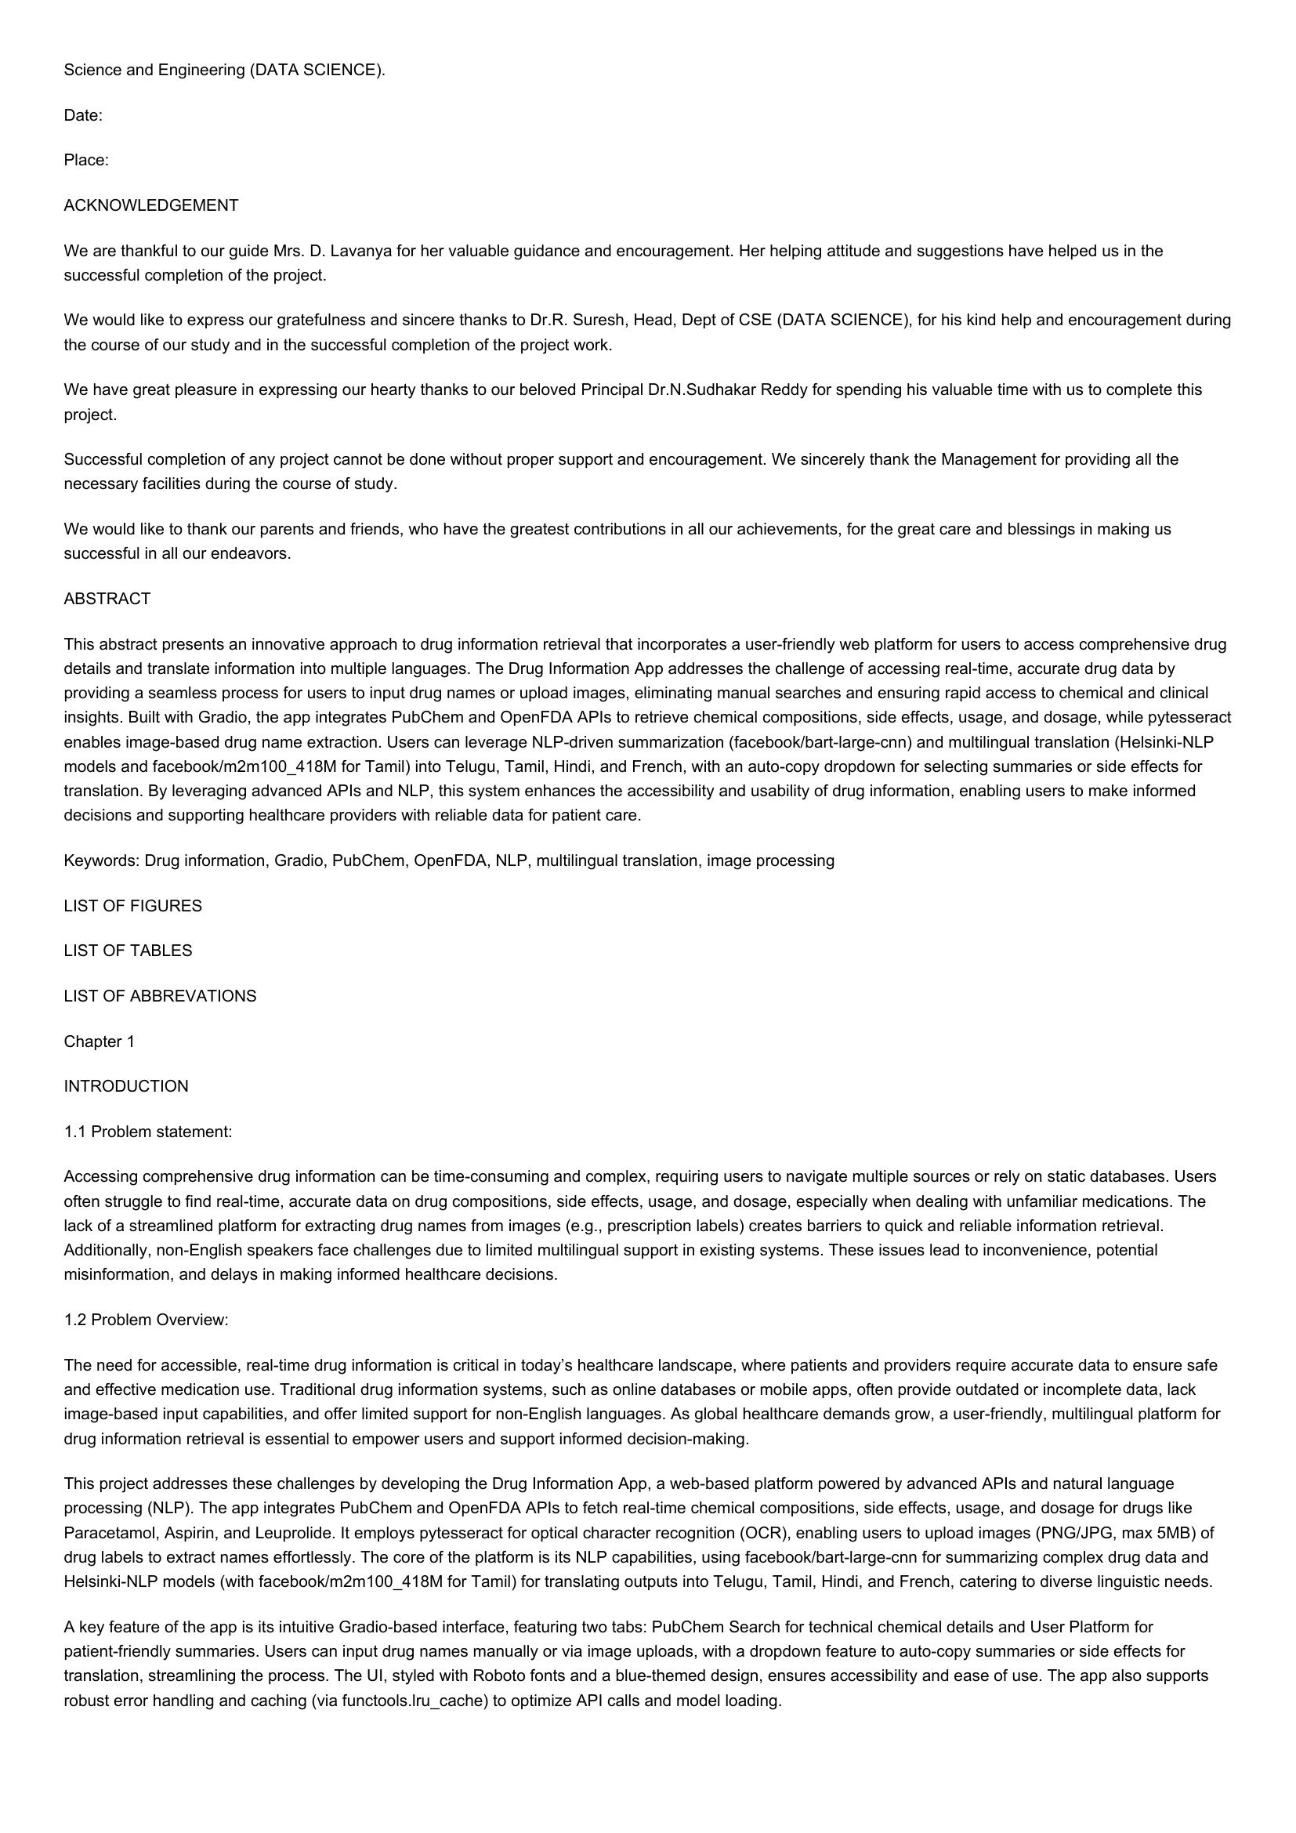

Science and Engineering (DATA SCIENCE).  
Date:  
  
Place:  
  
ACKNOWLEDGEMENT  
  
We are thankful to our guide Mrs. D. Lavanya for her valuable guidance and encouragement. Her helping attitude and suggestions have helped us in the  
successful completion of the project.  
  
We would like to express our gratefulness and sincere thanks to Dr.R. Suresh, Head, Dept of CSE (DATA SCIENCE), for his kind help and encouragement during  
the course of our study and in the successful completion of the project work.  
  
We have great pleasure in expressing our hearty thanks to our beloved Principal Dr.N.Sudhakar Reddy for spending his valuable time with us to complete this  
project.  
  
Successful completion of any project cannot be done without proper support and encouragement. We sincerely thank the Management for providing all the  
necessary facilities during the course of study.  
  
We would like to thank our parents and friends, who have the greatest contributions in all our achievements, for the great care and blessings in making us  
successful in all our endeavors.  
  
ABSTRACT  
  
This abstract presents an innovative approach to drug information retrieval that incorporates a user-friendly web platform for users to access comprehensive drug  
details and translate information into multiple languages. The Drug Information App addresses the challenge of accessing real-time, accurate drug data by  
providing a seamless process for users to input drug names or upload images, eliminating manual searches and ensuring rapid access to chemical and clinical  
insights. Built with Gradio, the app integrates PubChem and OpenFDA APIs to retrieve chemical compositions, side effects, usage, and dosage, while pytesseract  
enables image-based drug name extraction. Users can leverage NLP-driven summarization (facebook/bart-large-cnn) and multilingual translation (Helsinki-NLP  
models and facebook/m2m100_418M for Tamil) into Telugu, Tamil, Hindi, and French, with an auto-copy dropdown for selecting summaries or side effects for  
translation. By leveraging advanced APIs and NLP, this system enhances the accessibility and usability of drug information, enabling users to make informed  
decisions and supporting healthcare providers with reliable data for patient care.  
  
Keywords: Drug information, Gradio, PubChem, OpenFDA, NLP, multilingual translation, image processing  
LIST OF FIGURES  
  
LIST OF TABLES  
  
LIST OF ABBREVATIONS  
  
Chapter 1  
  
INTRODUCTION  
  
1.1 Problem statement:  
  
Accessing comprehensive drug information can be time-consuming and complex, requiring users to navigate multiple sources or rely on static databases. Users  
often struggle to find real-time, accurate data on drug compositions, side effects, usage, and dosage, especially when dealing with unfamiliar medications. The  
lack of a streamlined platform for extracting drug names from images (e.g., prescription labels) creates barriers to quick and reliable information retrieval.  
Additionally, non-English speakers face challenges due to limited multilingual support in existing systems. These issues lead to inconvenience, potential  
misinformation, and delays in making informed healthcare decisions.  
  
1.2 Problem Overview:  
  
The need for accessible, real-time drug information is critical in today’s healthcare landscape, where patients and providers require accurate data to ensure safe  
and effective medication use. Traditional drug information systems, such as online databases or mobile apps, often provide outdated or incomplete data, lack  
image-based input capabilities, and offer limited support for non-English languages. As global healthcare demands grow, a user-friendly, multilingual platform for  
drug information retrieval is essential to empower users and support informed decision-making.  
  
This project addresses these challenges by developing the Drug Information App, a web-based platform powered by advanced APIs and natural language  
processing (NLP). The app integrates PubChem and OpenFDA APIs to fetch real-time chemical compositions, side effects, usage, and dosage for drugs like  
Paracetamol, Aspirin, and Leuprolide. It employs pytesseract for optical character recognition (OCR), enabling users to upload images (PNG/JPG, max 5MB) of  
drug labels to extract names effortlessly. The core of the platform is its NLP capabilities, using facebook/bart-large-cnn for summarizing complex drug data and  
Helsinki-NLP models (with facebook/m2m100_418M for Tamil) for translating outputs into Telugu, Tamil, Hindi, and French, catering to diverse linguistic needs.  
  
A key feature of the app is its intuitive Gradio-based interface, featuring two tabs: PubChem Search for technical chemical details and User Platform for  
patient-friendly summaries. Users can input drug names manually or via image uploads, with a dropdown feature to auto-copy summaries or side effects for  
translation, streamlining the process. The UI, styled with Roboto fonts and a blue-themed design, ensures accessibility and ease of use. The app also supports  
robust error handling and caching (via functools.Iru_cache) to optimize API calls and model loading.

# Page 3

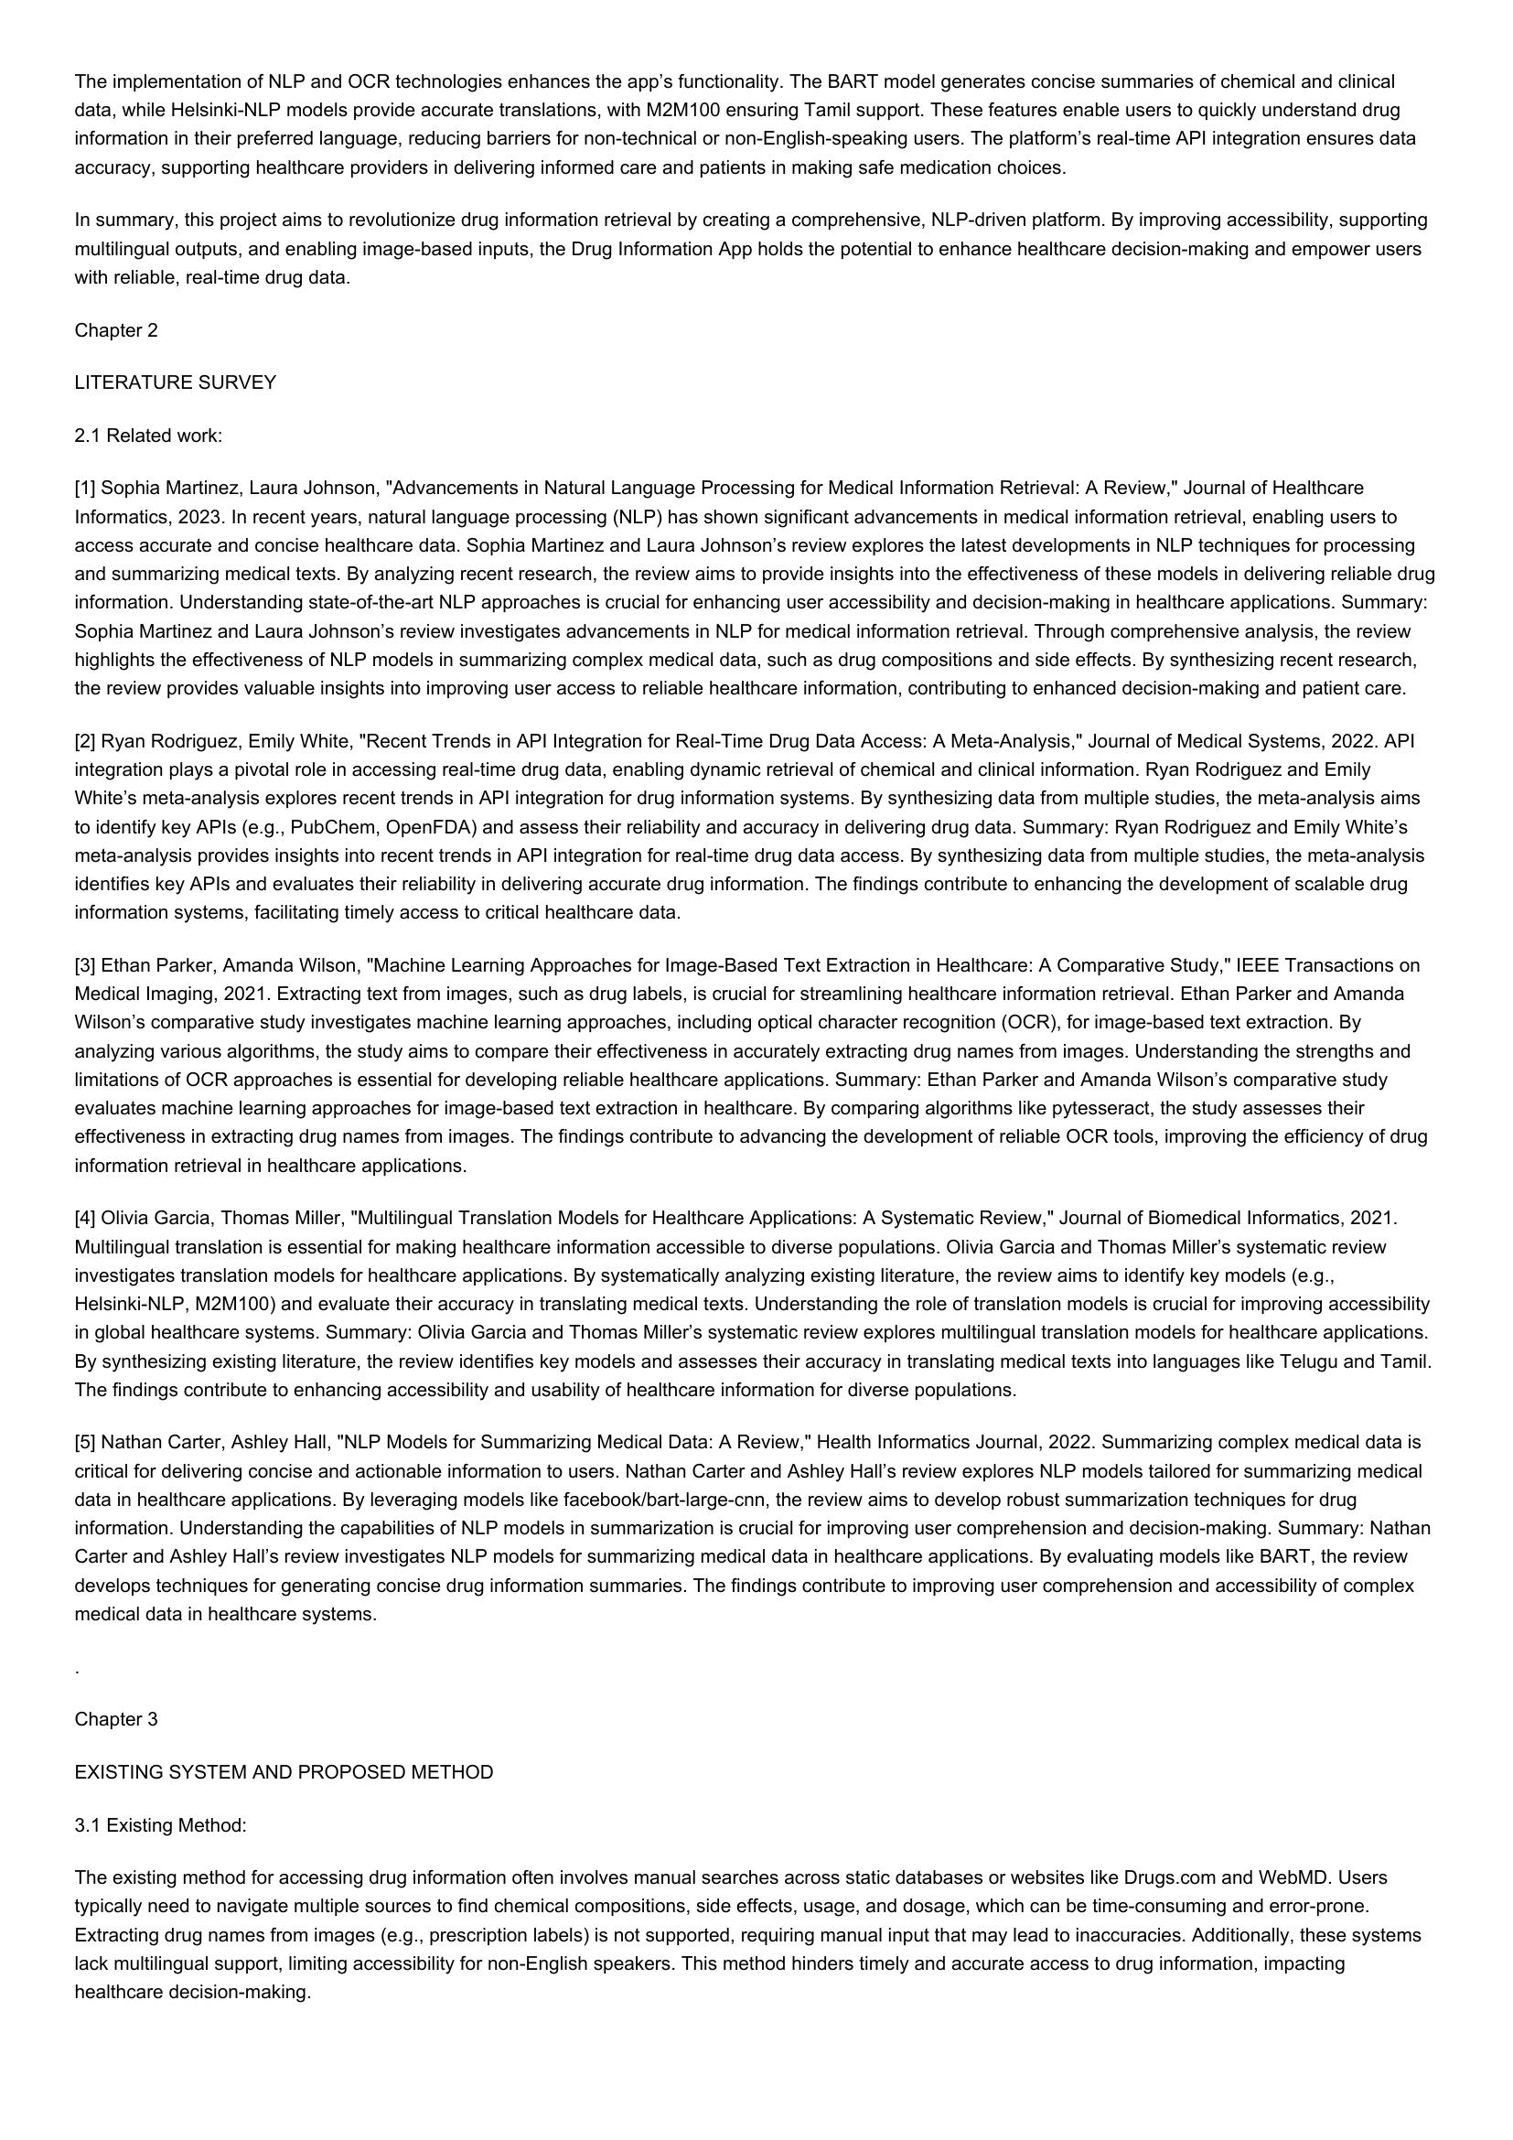

The implementation of NLP and OCR technologies enhances the app’s functionality. The BART model generates concise summaries of chemical and clinical  
data, while Helsinki-NLP models provide accurate translations, with M2M100 ensuring Tamil support. These features enable users to quickly understand drug  
information in their preferred language, reducing barriers for non-technical or non-English-speaking users. The platform’s real-time API integration ensures data  
accuracy, supporting healthcare providers in delivering informed care and patients in making safe medication choices.  
  
In summary, this project aims to revolutionize drug information retrieval by creating a comprehensive, NLP-driven platform. By improving accessibility, supporting  
multilingual outputs, and enabling image-based inputs, the Drug Information App holds the potential to enhance healthcare decision-making and empower users  
with reliable, real-time drug data.  
  
Chapter 2  
LITERATURE SURVEY  
2.1 Related work:  
  
[1] Sophia Martinez, Laura Johnson, "Advancements in Natural Language Processing for Medical Information Retrieval: A Review," Journal of Healthcare  
Informatics, 2023. In recent years, natural language processing (NLP) has shown significant advancements in medical information retrieval, enabling users to  
access accurate and concise healthcare data. Sophia Martinez and Laura Johnson’s review explores the latest developments in NLP techniques for processing  
and summarizing medical texts. By analyzing recent research, the review aims to provide insights into the effectiveness of these models in delivering reliable drug  
information. Understanding state-of-the-art NLP approaches is crucial for enhancing user accessibility and decision-making in healthcare applications. Summary:  
Sophia Martinez and Laura Johnson’s review investigates advancements in NLP for medical information retrieval. Through comprehensive analysis, the review  
highlights the effectiveness of NLP models in summarizing complex medical data, such as drug compositions and side effects. By synthesizing recent research,  
the review provides valuable insights into improving user access to reliable healthcare information, contributing to enhanced decision-making and patient care.  
  
[2] Ryan Rodriguez, Emily White, "Recent Trends in API Integration for Real-Time Drug Data Access: A Meta-Analysis," Journal of Medical Systems, 2022. API  
integration plays a pivotal role in accessing real-time drug data, enabling dynamic retrieval of chemical and clinical information. Ryan Rodriguez and Emily  
White’s meta-analysis explores recent trends in API integration for drug information systems. By synthesizing data from multiple studies, the meta-analysis aims  
to identify key APIs (e.g., PubChem, OpenFDA) and assess their reliability and accuracy in delivering drug data. Summary: Ryan Rodriguez and Emily White’s  
meta-analysis provides insights into recent trends in API integration for real-time drug data access. By synthesizing data from multiple studies, the meta-analysis  
identifies key APIs and evaluates their reliability in delivering accurate drug information. The findings contribute to enhancing the development of scalable drug  
information systems, facilitating timely access to critical healthcare data.  
  
[3] Ethan Parker, Amanda Wilson, "Machine Learning Approaches for Image-Based Text Extraction in Healthcare: A Comparative Study," IEEE Transactions on  
Medical Imaging, 2021. Extracting text from images, such as drug labels, is crucial for streamlining healthcare information retrieval. Ethan Parker and Amanda  
Wilson’s comparative study investigates machine learning approaches, including optical character recognition (OCR), for image-based text extraction. By  
analyzing various algorithms, the study aims to compare their effectiveness in accurately extracting drug names from images. Understanding the strengths and  
limitations of OCR approaches is essential for developing reliable healthcare applications. Summary: Ethan Parker and Amanda Wilson's comparative study  
evaluates machine learning approaches for image-based text extraction in healthcare. By comparing algorithms like pytesseract, the study assesses their  
effectiveness in extracting drug names from images. The findings contribute to advancing the development of reliable OCR tools, improving the efficiency of drug  
information retrieval in healthcare applications.  
  
[4] Olivia Garcia, Thomas Miller, "Multilingual Translation Models for Healthcare Applications: A Systematic Review," Journal of Biomedical Informatics, 2021.  
Multilingual translation is essential for making healthcare information accessible to diverse populations. Olivia Garcia and Thomas Miller’s systematic review  
investigates translation models for healthcare applications. By systematically analyzing existing literature, the review aims to identify key models (e.g.,  
Helsinki-NLP, M2M100) and evaluate their accuracy in translating medical texts. Understanding the role of translation models is crucial for improving accessibility  
in global healthcare systems. Summary: Olivia Garcia and Thomas Miller's systematic review explores multilingual translation models for healthcare applications.  
By synthesizing existing literature, the review identifies key models and assesses their accuracy in translating medical texts into languages like Telugu and Tamil.  
The findings contribute to enhancing accessibility and usability of healthcare information for diverse populations.  
  
[5] Nathan Carter, Ashley Hall, "NLP Models for Summarizing Medical Data: A Review," Health Informatics Journal, 2022. Summarizing complex medical data is  
critical for delivering concise and actionable information to users. Nathan Carter and Ashley Hall’s review explores NLP models tailored for summarizing medical  
data in healthcare applications. By leveraging models like facebook/bart-large-cnn, the review aims to develop robust summarization techniques for drug  
information. Understanding the capabilities of NLP models in summarization is crucial for improving user comprehension and decision-making. Summary: Nathan  
Carter and Ashley Hall’s review investigates NLP models for summarizing medical data in healthcare applications. By evaluating models like BART, the review  
develops techniques for generating concise drug information summaries. The findings contribute to improving user comprehension and accessibility of complex  
medical data in healthcare systems.  
  
Chapter 3  
EXISTING SYSTEM AND PROPOSED METHOD  
3.1 Existing Method:  
  
The existing method for accessing drug information often involves manual searches across static databases or websites like Drugs.com and WebMD. Users  
typically need to navigate multiple sources to find chemical compositions, side effects, usage, and dosage, which can be time-consuming and error-prone.  
Extracting drug names from images (e.g., prescription labels) is not supported, requiring manual input that may lead to inaccuracies. Additionally, these systems  
lack multilingual support, limiting accessibility for non-English speakers. This method hinders timely and accurate access to drug information, impacting  
healthcare decision-making.

# Page 4

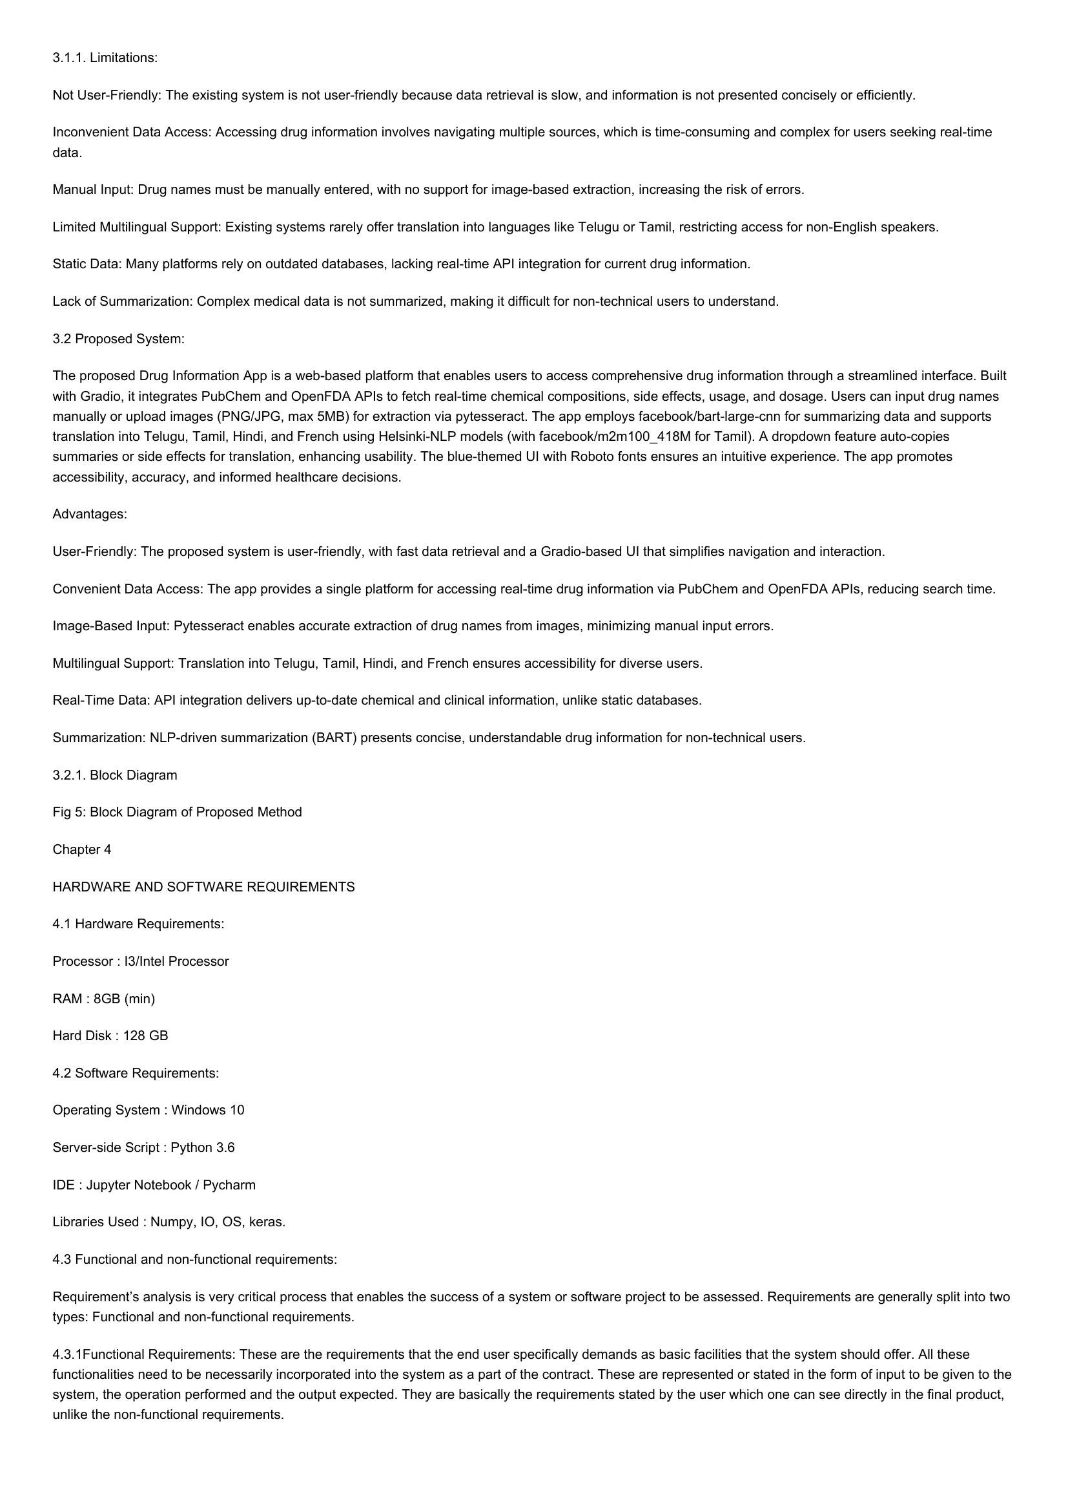

3.1.1. Limitations:  
Not User-Friendly: The existing system is not user-friendly because data retrieval is slow, and information is not presented concisely or efficiently.  
  
Inconvenient Data Access: Accessing drug information involves navigating multiple sources, which is time-consuming and complex for users seeking real-time  
data.  
  
Manual Input: Drug names must be manually entered, with no support for image-based extraction, increasing the risk of errors.  
  
Limited Multilingual Support: Existing systems rarely offer translation into languages like Telugu or Tamil, restricting access for non-English speakers.  
Static Data: Many platforms rely on outdated databases, lacking real-time API integration for current drug information.  
  
Lack of Summarization: Complex medical data is not summarized, making it difficult for non-technical users to understand.  
  
3.2 Proposed System:  
  
The proposed Drug Information App is a web-based platform that enables users to access comprehensive drug information through a streamlined interface. Built  
with Gradio, it integrates PubChem and OpenFDA APIs to fetch real-time chemical compositions, side effects, usage, and dosage. Users can input drug names  
manually or upload images (PNG/JPG, max 5MB) for extraction via pytesseract. The app employs facebook/bart-large-cnn for summarizing data and supports  
translation into Telugu, Tamil, Hindi, and French using Helsinki-NLP models (with facebook/m2m100_418M for Tamil). A dropdown feature auto-copies  
summaries or side effects for translation, enhancing usability. The blue-themed UI with Roboto fonts ensures an intuitive experience. The app promotes  
accessibility, accuracy, and informed healthcare decisions.  
  
Advantages:  
  
User-Friendly: The proposed system is user-friendly, with fast data retrieval and a Gradio-based UI that simplifies navigation and interaction.  
Convenient Data Access: The app provides a single platform for accessing real-time drug information via PubChem and OpenFDA APIs, reducing search time.  
Image-Based Input: Pytesseract enables accurate extraction of drug names from images, minimizing manual input errors.  
Multilingual Support: Translation into Telugu, Tamil, Hindi, and French ensures accessibility for diverse users.  
  
Real-Time Data: API integration delivers up-to-date chemical and clinical information, unlike static databases.  
  
Summarization: NLP-driven summarization (BART) presents concise, understandable drug information for non-technical users.  
3.2.1. Block Diagram  
  
Fig 5: Block Diagram of Proposed Method  
  
Chapter 4  
  
HARDWARE AND SOFTWARE REQUIREMENTS  
  
4.1 Hardware Requirements:  
  
Processor : I3/Intel Processor  
  
RAM : 8GB (min)  
  
Hard Disk : 128 GB  
  
4.2 Software Requirements:  
  
Operating System : Windows 10  
  
Server-side Script : Python 3.6  
  
IDE : Jupyter Notebook / Pycharm  
  
Libraries Used : Numpy, IO, OS, keras.  
  
4.3 Functional and non-functional requirements:  
  
Requirement’s analysis is very critical process that enables the success of a system or software project to be assessed. Requirements are generally split into two  
types: Functional and non-functional requirements.  
  
4.3.1Functional Requirements: These are the requirements that the end user specifically demands as basic facilities that the system should offer. All these  
functionalities need to be necessarily incorporated into the system as a part of the contract. These are represented or stated in the form of input to be given to the  
system, the operation performed and the output expected. They are basically the requirements stated by the user which one can see directly in the final product,  
unlike the non-functional requirements.

# Page 5

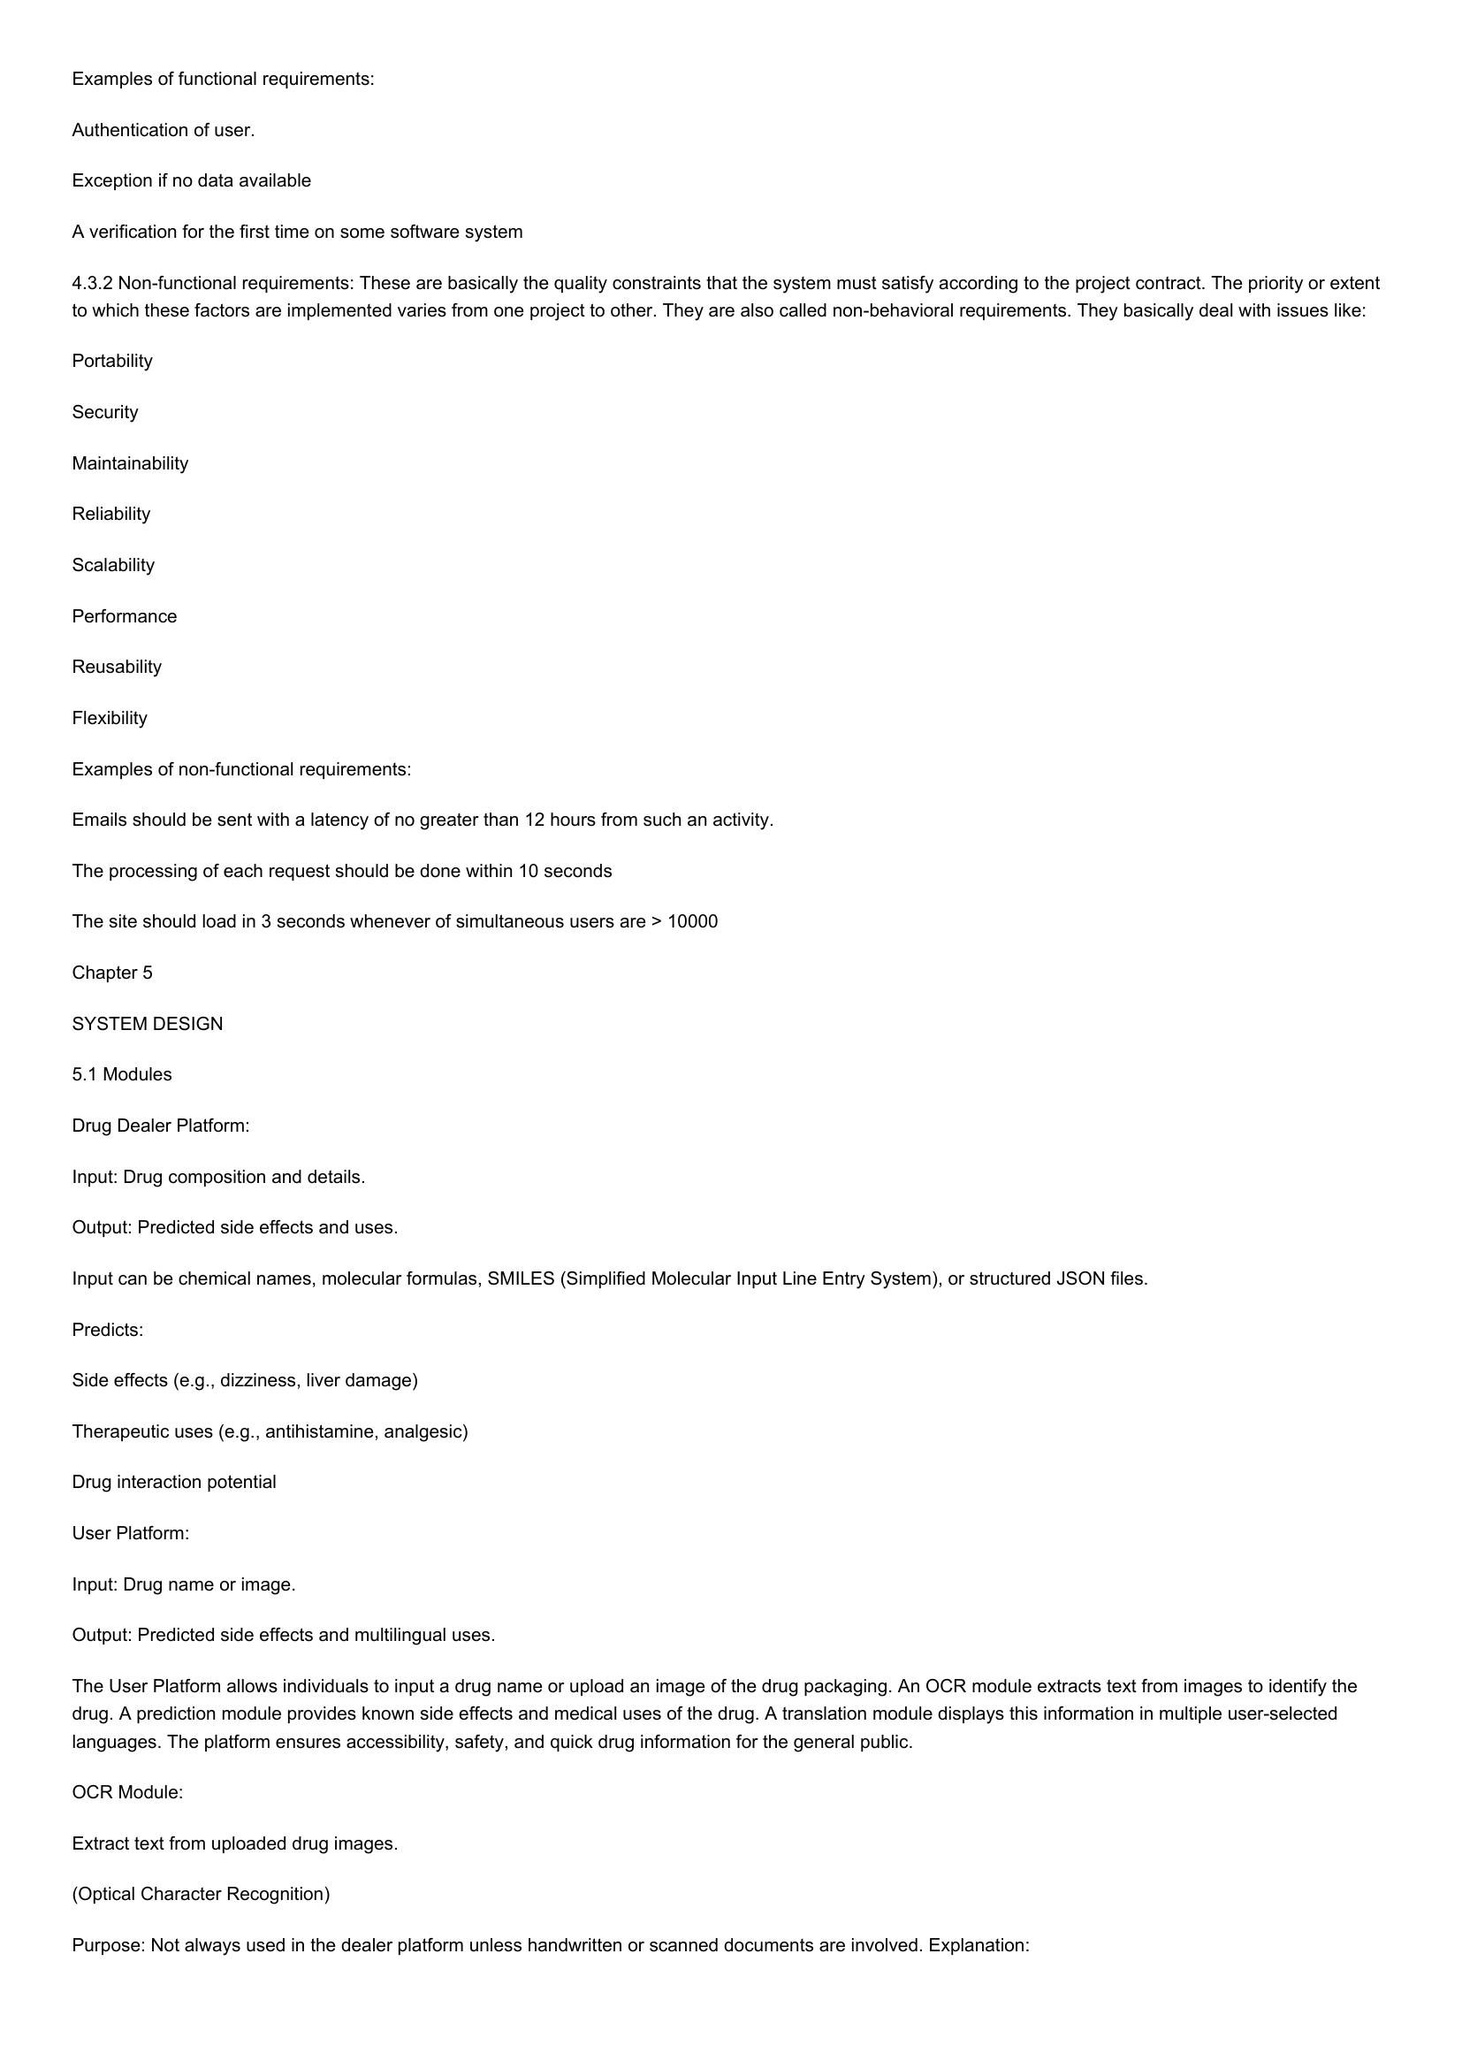

Examples of functional requirements:  
  
Authentication of user.  
  
Exception if no data available  
  
A verification for the first time on some software system  
  
4.3.2 Non-functional requirements: These are basically the quality constraints that the system must satisfy according to the project contract. The priority or extent  
to which these factors are implemented varies from one project to other. They are also called non-behavioral requirements. They basically deal with issues like:  
  
Portability  
  
Security  
  
Maintainability  
  
Reliability  
  
Scalability  
  
Performance  
  
Reusability  
  
Flexibility  
  
Examples of non-functional requirements:  
  
Emails should be sent with a latency of no greater than 12 hours from such an activity.  
The processing of each request should be done within 10 seconds  
  
The site should load in 3 seconds whenever of simultaneous users are > 10000  
Chapter 5  
  
SYSTEM DESIGN  
  
5.1 Modules  
  
Drug Dealer Platform:  
  
Input: Drug composition and details.  
  
Output: Predicted side effects and uses.  
  
Input can be chemical names, molecular formulas, SMILES (Simplified Molecular Input Line Entry System), or structured JSON files.  
Predicts:  
  
Side effects (e.g., dizziness, liver damage)  
  
Therapeutic uses (e.g., antihistamine, analgesic)  
  
Drug interaction potential  
  
User Platform:  
  
Input: Drug name or image.  
  
Output: Predicted side effects and multilingual uses.  
  
The User Platform allows individuals to input a drug name or upload an image of the drug packaging. An OCR module extracts text from images to identify the  
drug. A prediction module provides known side effects and medical uses of the drug. A translation module displays this information in multiple user-selected  
languages. The platform ensures accessibility, safety, and quick drug information for the general public.  
  
OCR Module:  
Extract text from uploaded drug images.  
(Optical Character Recognition)  
  
Purpose: Not always used in the dealer platform unless handwritten or scanned documents are involved. Explanation:

# Page 6

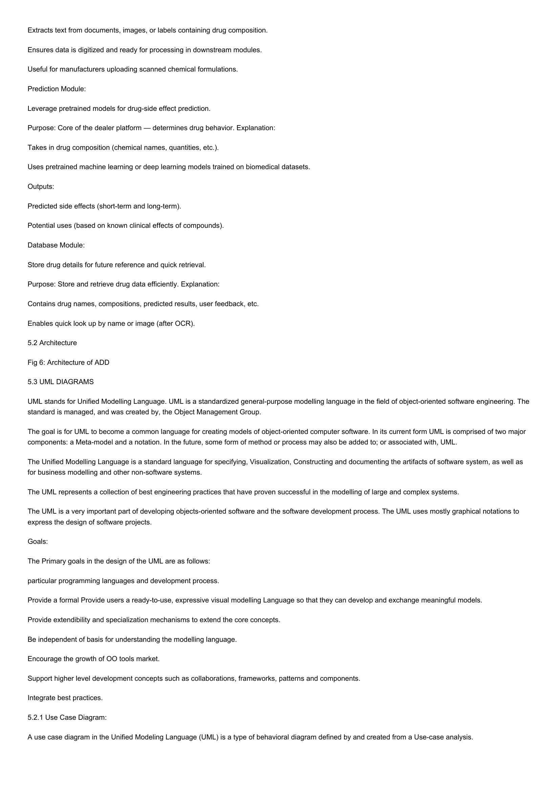

Extracts text from documents, images, or labels containing drug composition.  
Ensures data is digitized and ready for processing in downstream modules.  
Useful for manufacturers uploading scanned chemical formulations.  
  
Prediction Module:  
  
Leverage pretrained models for drug-side effect prediction.  
  
Purpose: Core of the dealer platform — determines drug behavior. Explanation:  
Takes in drug composition (chemical names, quantities, etc.).  
  
Uses pretrained machine learning or deep learning models trained on biomedical datasets.  
Outputs:  
  
Predicted side effects (short-term and long-term).  
  
Potential uses (based on known clinical effects of compounds).  
  
Database Module:  
  
Store drug details for future reference and quick retrieval.  
  
Purpose: Store and retrieve drug data efficiently. Explanation:  
  
Contains drug names, compositions, predicted results, user feedback, etc.  
Enables quick look up by name or image (after OCR).  
  
5.2 Architecture  
  
Fig 6: Architecture of ADD  
  
5.3 UML DIAGRAMS  
  
UML stands for Unified Modelling Language. UML is a standardized general-purpose modelling language in the field of object-oriented software engineering. The  
standard is managed, and was created by, the Object Management Group.  
  
The goal is for UML to become a common language for creating models of object-oriented computer software. In its current form UML is comprised of two major  
components: a Meta-model and a notation. In the future, some form of method or process may also be added to; or associated with, UML.  
  
The Unified Modelling Language is a standard language for specifying, Visualization, Constructing and documenting the artifacts of software system, as well as  
for business modelling and other non-software systems.  
  
The UML represents a collection of best engineering practices that have proven successful in the modelling of large and complex systems.  
  
The UML is a very important part of developing objects-oriented software and the software development process. The UML uses mostly graphical notations to  
express the design of software projects.  
  
Goals:  
  
The Primary goals in the design of the UML are as follows:  
  
particular programming languages and development process.  
  
Provide a formal Provide users a ready-to-use, expressive visual modelling Language so that they can develop and exchange meaningful models.  
Provide extendibility and specialization mechanisms to extend the core concepts.  
  
Be independent of basis for understanding the modelling language.  
  
Encourage the growth of OO tools market.  
  
Support higher level development concepts such as collaborations, frameworks, patterns and components.  
  
Integrate best practices.  
  
5.2.1 Use Case Diagram:  
  
Ause case diagram in the Unified Modeling Language (UML) is a type of behavioral diagram defined by and created from a Use-case analysis.

# Page 7

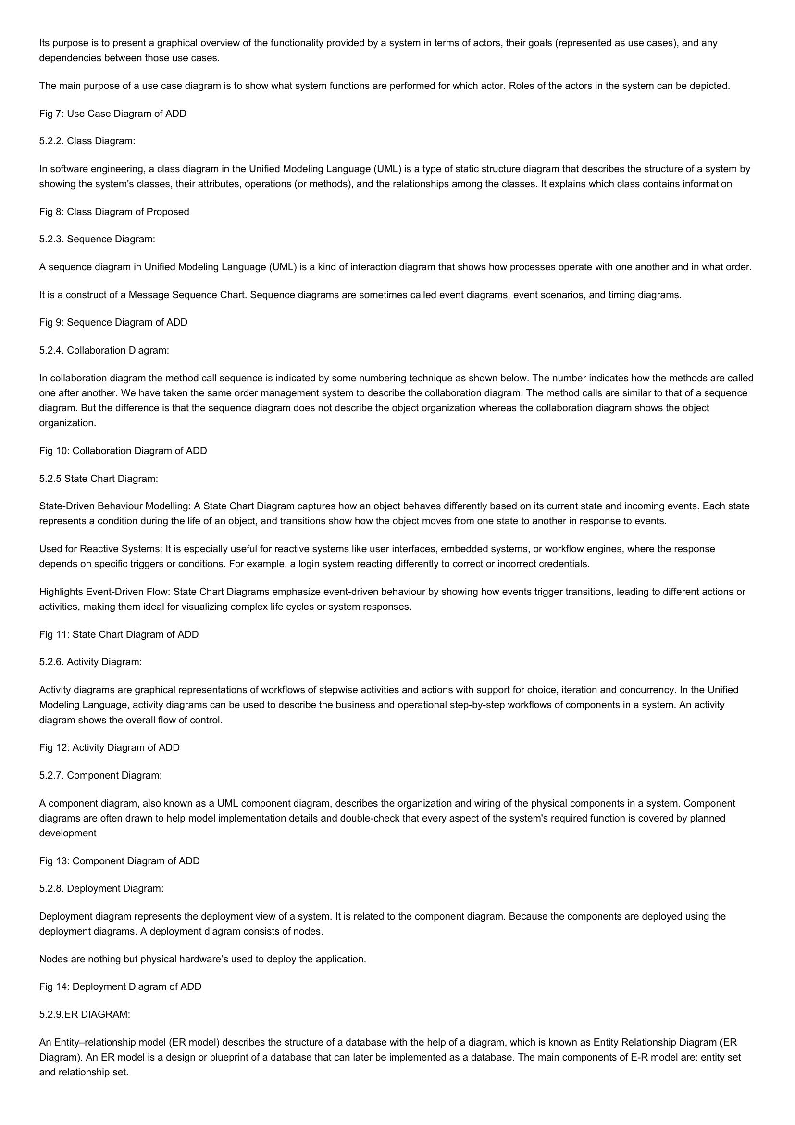

Its purpose is to present a graphical overview of the functionality provided by a system in terms of actors, their goals (represented as use cases), and any  
dependencies between those use cases.  
  
The main purpose of a use case diagram is to show what system functions are performed for which actor. Roles of the actors in the system can be depicted.  
Fig 7: Use Case Diagram of ADD  
5.2.2. Class Diagram:  
  
In software engineering, a class diagram in the Unified Modeling Language (UML) is a type of static structure diagram that describes the structure of a system by  
showing the system's classes, their attributes, operations (or methods), and the relationships among the classes. It explains which class contains information  
  
Fig 8: Class Diagram of Proposed  
  
5.2.3. Sequence Diagram:  
  
A sequence diagram in Unified Modeling Language (UML) is a kind of interaction diagram that shows how processes operate with one another and in what order.  
It is a construct of a Message Sequence Chart. Sequence diagrams are sometimes called event diagrams, event scenarios, and timing diagrams.  
  
Fig 9: Sequence Diagram of ADD  
  
5.2.4. Collaboration Diagram:  
  
In collaboration diagram the method call sequence is indicated by some numbering technique as shown below. The number indicates how the methods are called  
one after another. We have taken the same order management system to describe the collaboration diagram. The method calls are similar to that of a sequence  
  
diagram. But the difference is that the sequence diagram does not describe the object organization whereas the collaboration diagram shows the object  
organization.  
  
Fig 10: Collaboration Diagram of ADD  
5.2.5 State Chart Diagram:  
  
State-Driven Behaviour Modelling: A State Chart Diagram captures how an object behaves differently based on its current state and incoming events. Each state  
represents a condition during the life of an object, and transitions show how the object moves from one state to another in response to events.  
  
Used for Reactive Systems: It is especially useful for reactive systems like user interfaces, embedded systems, or workflow engines, where the response  
depends on specific triggers or conditions. For example, a login system reacting differently to correct or incorrect credentials.  
  
Highlights Event-Driven Flow: State Chart Diagrams emphasize event-driven behaviour by showing how events trigger transitions, leading to different actions or  
activities, making them ideal for visualizing complex life cycles or system responses.  
  
Fig 11: State Chart Diagram of ADD  
5.2.6. Activity Diagram:  
  
Activity diagrams are graphical representations of workflows of stepwise activities and actions with support for choice, iteration and concurrency. In the Unified  
Modeling Language, activity diagrams can be used to describe the business and operational step-by-step workflows of components in a system. An activity  
diagram shows the overall flow of control.  
  
Fig 12: Activity Diagram of ADD  
5.2.7. Component Diagram:  
  
Acomponent diagram, also known as a UML component diagram, describes the organization and wiring of the physical components in a system. Component  
diagrams are often drawn to help model implementation details and double-check that every aspect of the system's required function is covered by planned  
development  
  
Fig 13: Component Diagram of ADD  
5.2.8. Deployment Diagram:  
  
Deployment diagram represents the deployment view of a system. It is related to the component diagram. Because the components are deployed using the  
deployment diagrams. A deployment diagram consists of nodes.  
  
Nodes are nothing but physical hardware’s used to deploy the application.  
Fig 14: Deployment Diagram of ADD  
5.2.9.ER DIAGRAM:  
  
An Entity-relationship model (ER model) describes the structure of a database with the help of a diagram, which is known as Entity Relationship Diagram (ER  
Diagram). An ER model is a design or blueprint of a database that can later be implemented as a database. The main components of E-R model are: entity set  
and relationship set.

# Page 8

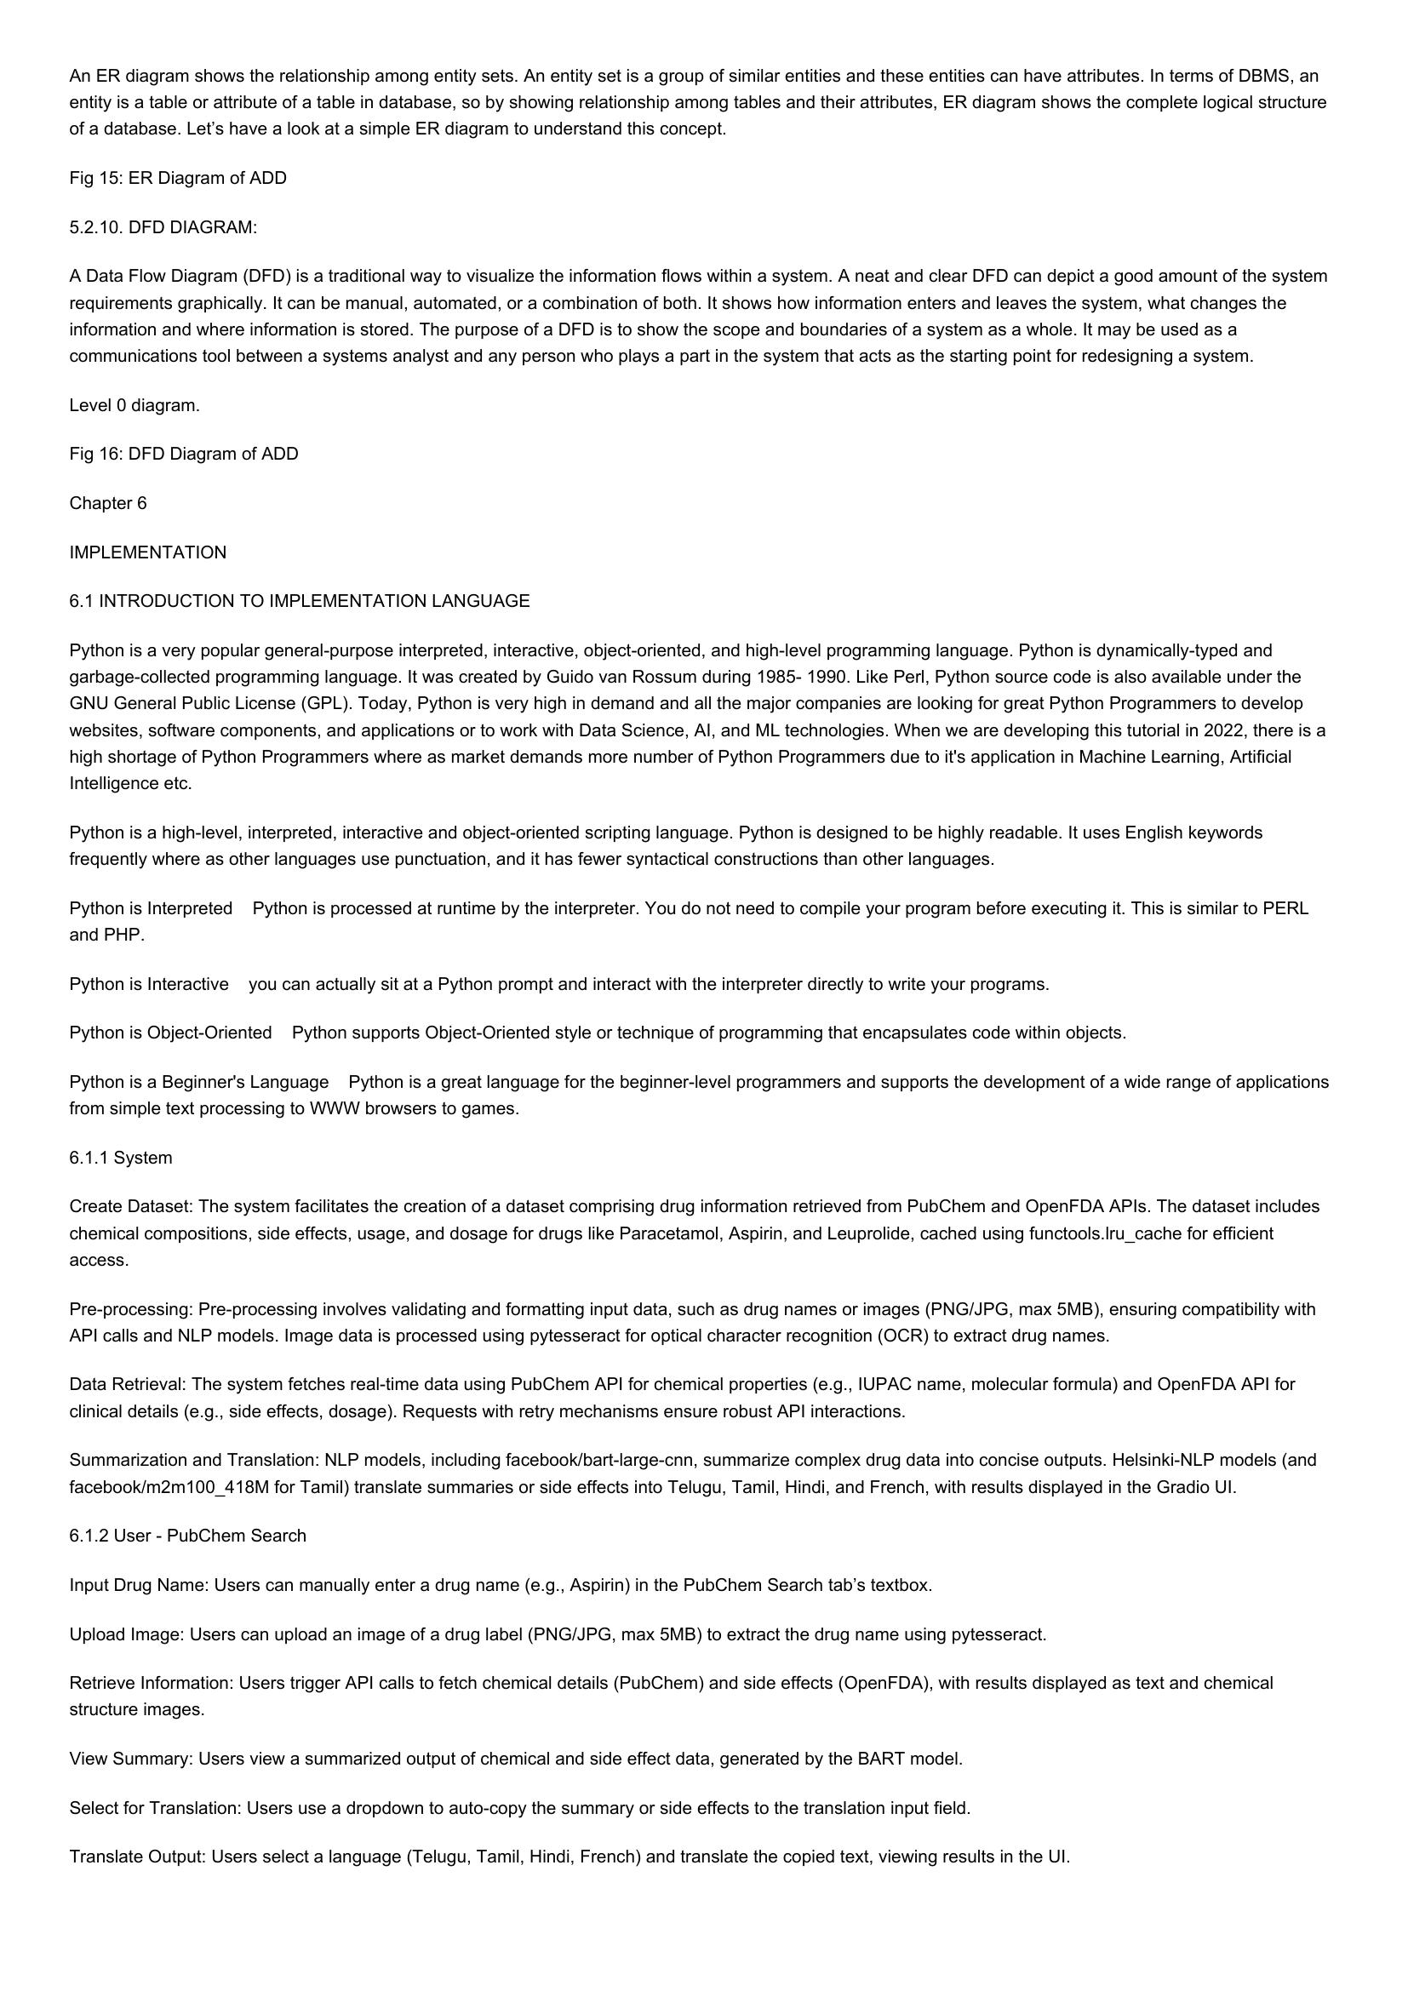

An ER diagram shows the relationship among entity sets. An entity set is a group of similar entities and these entities can have attributes. In terms of DBMS, an  
entity is a table or attribute of a table in database, so by showing relationship among tables and their attributes, ER diagram shows the complete logical structure  
of a database. Let’s have a look at a simple ER diagram to understand this concept.  
  
Fig 15: ER Diagram of ADD  
5.2.10. DFD DIAGRAM:  
  
A Data Flow Diagram (DFD) is a traditional way to visualize the information flows within a system. A neat and clear DFD can depict a good amount of the system  
requirements graphically. It can be manual, automated, or a combination of both. It shows how information enters and leaves the system, what changes the  
information and where information is stored. The purpose of a DFD is to show the scope and boundaries of a system as a whole. It may be used as a  
communications tool between a systems analyst and any person who plays a part in the system that acts as the starting point for redesigning a system.  
  
Level 0 diagram.  
  
Fig 16: DFD Diagram of ADD  
  
Chapter 6  
  
IMPLEMENTATION  
  
6.1 INTRODUCTION TO IMPLEMENTATION LANGUAGE  
  
Python is a very popular general-purpose interpreted, interactive, object-oriented, and high-level programming language. Python is dynamically-typed and  
garbage-collected programming language. It was created by Guido van Rossum during 1985- 1990. Like Perl, Python source code is also available under the  
GNU General Public License (GPL). Today, Python is very high in demand and all the major companies are looking for great Python Programmers to develop  
websites, software components, and applications or to work with Data Science, Al, and ML technologies. When we are developing this tutorial in 2022, there is a  
high shortage of Python Programmers where as market demands more number of Python Programmers due to it's application in Machine Learning, Artificial  
Intelligence etc.  
  
Python is a high-level, interpreted, interactive and object-oriented scripting language. Python is designed to be highly readable. It uses English keywords  
frequently where as other languages use punctuation, and it has fewer syntactical constructions than other languages.  
  
Python is Interpreted Python is processed at runtime by the interpreter. You do not need to compile your program before executing it. This is similar to PERL  
and PHP.  
  
Python is Interactive you can actually sit at a Python prompt and interact with the interpreter directly to write your programs.  
Python is Object-Oriented Python supports Object-Oriented style or technique of programming that encapsulates code within objects.  
  
Python is a Beginner's Language Python is a great language for the beginner-level programmers and supports the development of a wide range of applications  
from simple text processing to WWW browsers to games.  
  
6.1.1 System  
  
Create Dataset: The system facilitates the creation of a dataset comprising drug information retrieved from PubChem and OpenFDA APIs. The dataset includes  
chemical compositions, side effects, usage, and dosage for drugs like Paracetamol, Aspirin, and Leuprolide, cached using functools.lru_cache for efficient  
access.  
  
Pre-processing: Pre-processing involves validating and formatting input data, such as drug names or images (PNG/JPG, max 5MB), ensuring compatibility with  
API calls and NLP models. Image data is processed using pytesseract for optical character recognition (OCR) to extract drug names.  
  
Data Retrieval: The system fetches real-time data using PubChem API for chemical properties (e.g., IUPAC name, molecular formula) and OpenFDA API for  
clinical details (e.g., side effects, dosage). Requests with retry mechanisms ensure robust API interactions.  
  
Summarization and Translation: NLP models, including facebook/bart-large-cnn, summarize complex drug data into concise outputs. Helsinki-NLP models (and  
facebook/m2m100_418M for Tamil) translate summaries or side effects into Telugu, Tamil, Hindi, and French, with results displayed in the Gradio UI.  
  
6.1.2 User - PubChem Search  
Input Drug Name: Users can manually enter a drug name (e.g., Aspirin) in the PubChem Search tab’s textbox.  
Upload Image: Users can upload an image of a drug label (PNG/JPG, max 5MB) to extract the drug name using pytesseract.  
  
Retrieve Information: Users trigger API calls to fetch chemical details (PubChem) and side effects (OpenFDA), with results displayed as text and chemical  
structure images.  
  
View Summary: Users view a summarized output of chemical and side effect data, generated by the BART model.  
Select for Translation: Users use a dropdown to auto-copy the summary or side effects to the translation input field.  
  
Translate Output: Users select a language (Telugu, Tamil, Hindi, French) and translate the copied text, viewing results in the UI.

# Page 9

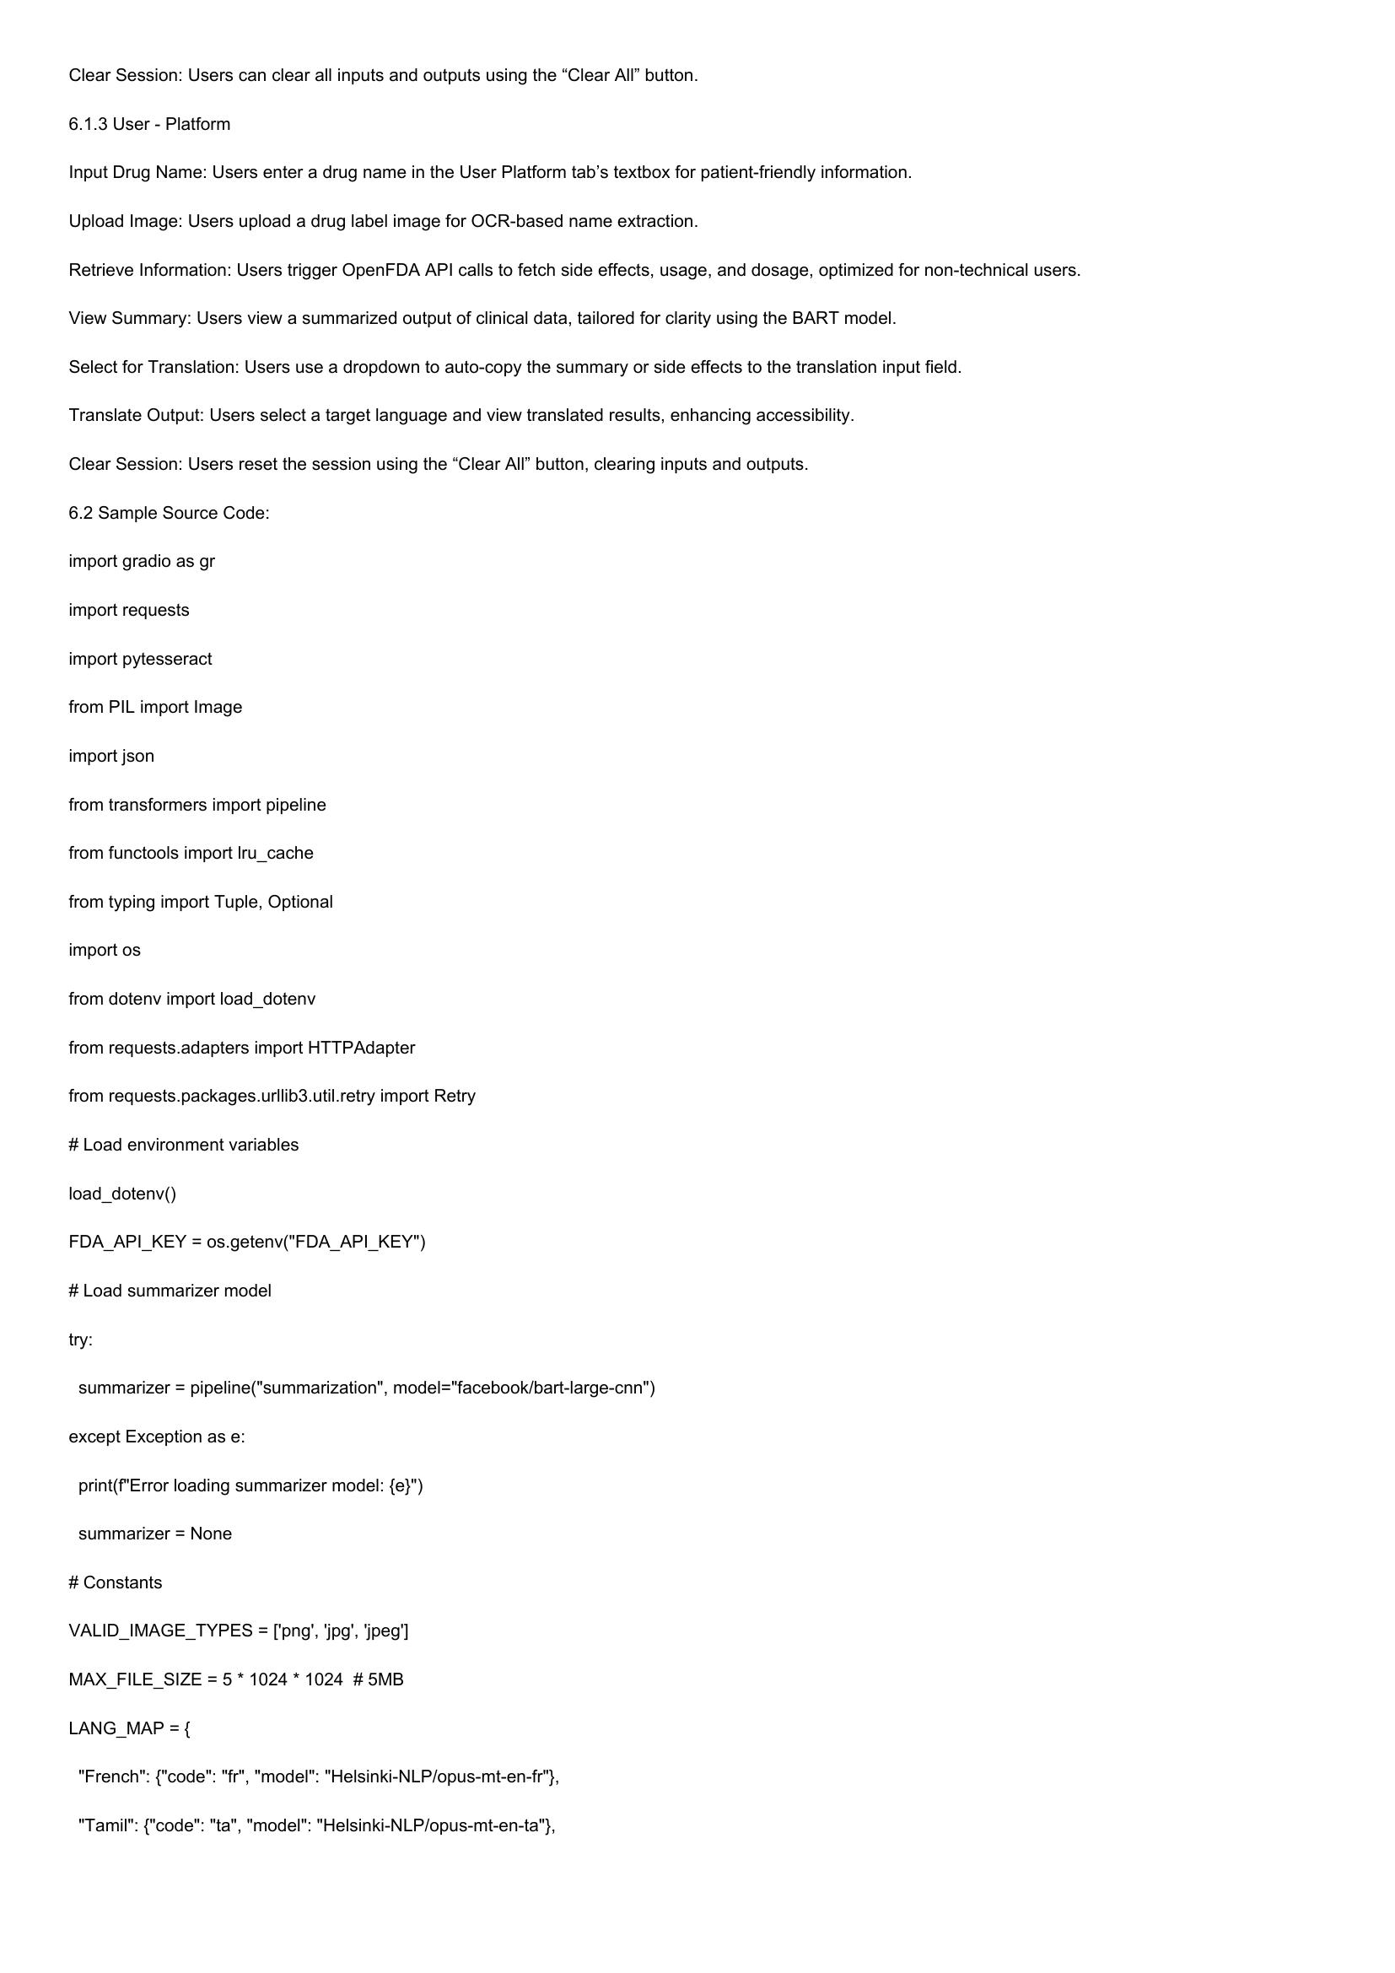

Clear Session: Users can clear all inputs and outputs using the “Clear All” button.  
6.1.3 User - Platform  
Input Drug Name: Users enter a drug name in the User Platform tab’s textbox for patient-friendly information.  
Upload Image: Users upload a drug label image for OCR-based name extraction.  
Retrieve Information: Users trigger OpenFDA API calls to fetch side effects, usage, and dosage, optimized for non-technical users.  
View Summary: Users view a summarized output of clinical data, tailored for clarity using the BART model.  
Select for Translation: Users use a dropdown to auto-copy the summary or side effects to the translation input field.  
Translate Output: Users select a target language and view translated results, enhancing accessibility.  
Clear Session: Users reset the session using the “Clear All” button, clearing inputs and outputs.  
6.2 Sample Source Code:  
import gradio as gr  
import requests  
import pytesseract  
from PIL import Image  
import json  
from transformers import pipeline  
from functools import Iru_cache  
from typing import Tuple, Optional  
import os  
from dotenv import load_dotenv  
from requests.adapters import HTTPAdapter  
from requests.packages.urllib3.util.retry import Retry  
# Load environment variables  
load_dotenv()  
FDA_API_KEY = os.getenv("FDA_API_KEY")  
# Load summarizer model  
try:  
summarizer = pipeline("summarization", model="facebook/bart-large-cnn")  
except Exception as e:  
print(f'Error loading summarizer model: {e}")  
summarizer = None  
# Constants  
VALID_IMAGE_TYPES = ['png', ‘jpg’, 'jpeg']  
MAX_FILE_SIZE = 5 * 1024 * 1024 #5MB  
LANG_MAP ={  
"French": {"code": "fr", "model": "Helsinki-NLP/opus-mt-en-fr"},  
  
"Tami  
  
jelsinki-NLP/opus-mt-en-ta"},

# Page 10

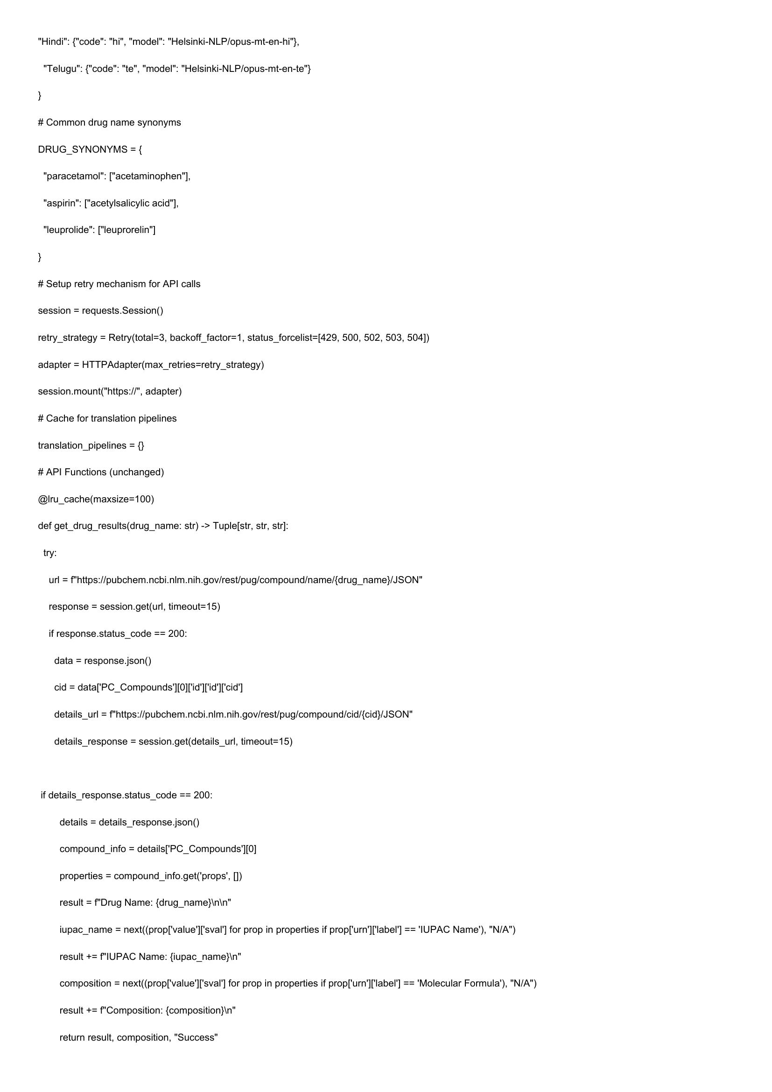

"Hindi": {"code": "hi", "model": "Helsinki-NLP/opus-mt-en-hi"},  
  
"Telugu": {"code": "te", "model": "Helsinki-NLP/opus-mt-en-te"}  
  
# Common drug name synonyms  
  
DRUG_SYNONYMS = {  
  
“paracetamol”: ["acetaminophen"],  
  
“aspirin”: ["acetylsalicylic acid"),  
  
"leuprolide": ["leuprorelin"]  
  
# Setup retry mechanism for API calls  
  
session = requests.Session()  
  
retry_strategy = Retry(total=3, backoff_factor=1, status_forcelist=[429, 500, 502, 503, 504])  
  
adapter = HTTPAdapter(max_retries=retry_strategy)  
  
session.mount("https://", adapter)  
  
# Cache for translation pipelines  
  
translation_pipelines = {}  
  
# API Functions (unchanged)  
  
@lru_cache(maxsize=100)  
  
def get_drug_results(drug_name: str) -> Tuple[str, str, str]:  
  
try:  
  
url = f"https://pubchem.ncbi.nim.nih.gov/rest/pug/compound/name/{drug_name}/JSON"  
  
response = session.get(url, timeout=15)  
  
if response.status_code == 200:  
  
data = response.json()  
  
cid = data['PC_Compounds'][0]['id'I['id'I[ cid’)  
  
details_url = f"https://pubchem.ncbi.nlm.nih.gov/rest/pug/compound/cid/{cid}/JSON"  
  
details_response = session.get(details_url, timeout=15)  
  
if details_response.status_code == 200:  
  
details = details_response.json()  
  
compound_info = details['PC_Compounds'][0]  
  
properties = compound_info.get(‘props’, [])  
  
result = f'Drug Name: {drug_name}\n\n"  
  
iupac_name = next((prop['value']['sval'] for prop in properties if prop['urn']['label'] == IUPAC Name’), "N/A")  
  
result += f"IUPAC Name: {iupac_name}\n"  
  
composition = next((prop['value']['sval'] for prop in properties if prop['urn'][label'] == 'Molecular Formula’), "N/A")  
  
result += f'Composition: {composition}\n"  
  
return result, composition, "Success"

# Page 11

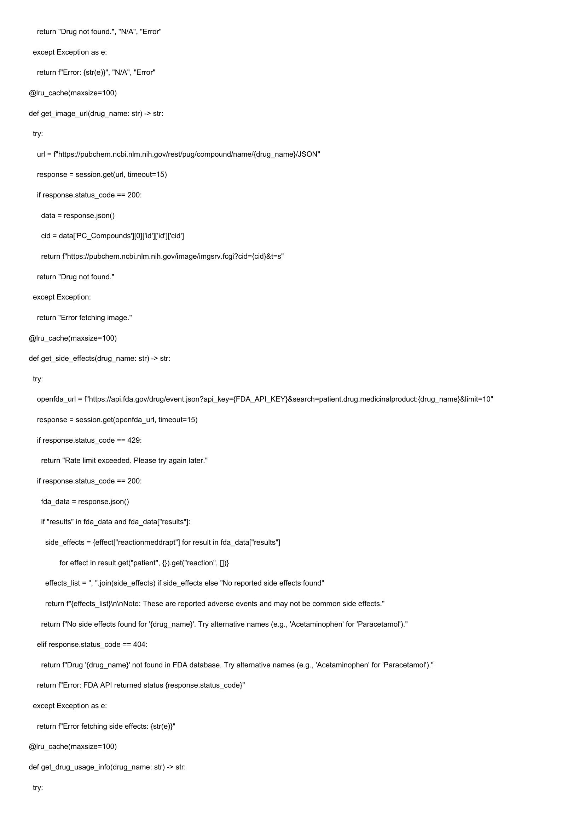

return "Drug not found.", "N/A", "Error"  
  
except Exception as e:  
  
return f"Error: {str(e)}", "N/A", "Error"  
  
@lru_cache(maxsize=100)  
  
def get_image_url(drug_name: str) -> str:  
  
try:  
  
url = f"https://pubchem.ncbi.nim.nih.gov/rest/pug/compound/name/{drug_name}/JSON"  
  
response = session.get(url, timeout=15)  
  
if response.status_code == 200:  
  
data = response.json()  
  
cid = data['PC_Compounds'][0]['id'I['id'I[ cid’)  
  
return f"https://pubchem.ncbi.nIm.nih.gov/image/imgsrv.fcgi?cid={cid}&t=s"  
  
return "Drug not found."  
  
except Exception:  
  
return "Error fetching image."  
  
@lru_cache(maxsize=100)  
  
def get_side_effects(drug_name: str) -> str:  
  
try:  
  
openfda_url = f"https://api.fda.gov/drug/event.json?api_key={FDA_API_KEY}&search=patient.drug.medicinalproduct:{drug_name}&limit=10"  
  
response = session.get(openfda_url, timeout=15)  
  
if response.status_code == 429:  
  
return "Rate limit exceeded. Please try again later."  
  
if response.status_code == 200:  
  
fda_data = response.json()  
  
if "results" in fda_data and fda_data["results"]:  
  
side_effects = {effect["reactionmeddrapt"] for result in fda_data["results"]  
  
for effect in result.get("patient", {}).get("reaction", [])}  
  
effects_list = ", "join(side_effects) if side_effects else "No reported side effects found"  
  
return f"{effects_list}\n\nNote: These are reported adverse events and may not be common side effects."  
  
return f"No side effects found for '{drug_name}'. Try alternative names (e.g., ‘Acetaminophen’ for 'Paracetamol')."  
  
elif response.status_code == 404:  
  
return f"Drug '{drug_name}' not found in FDA database. Try alternative names (e.g., ‘Acetaminophen’ for 'Paracetamol’)."  
  
return f"Error: FDA API returned status {response.status_code}"  
  
except Exception as e:  
  
return f"Error fetching side effects: {str(e)}"  
  
@lru_cache(maxsize=100)  
  
def get_drug_usage_info(drug_name: str) -> str:  
  
try:

# Page 12

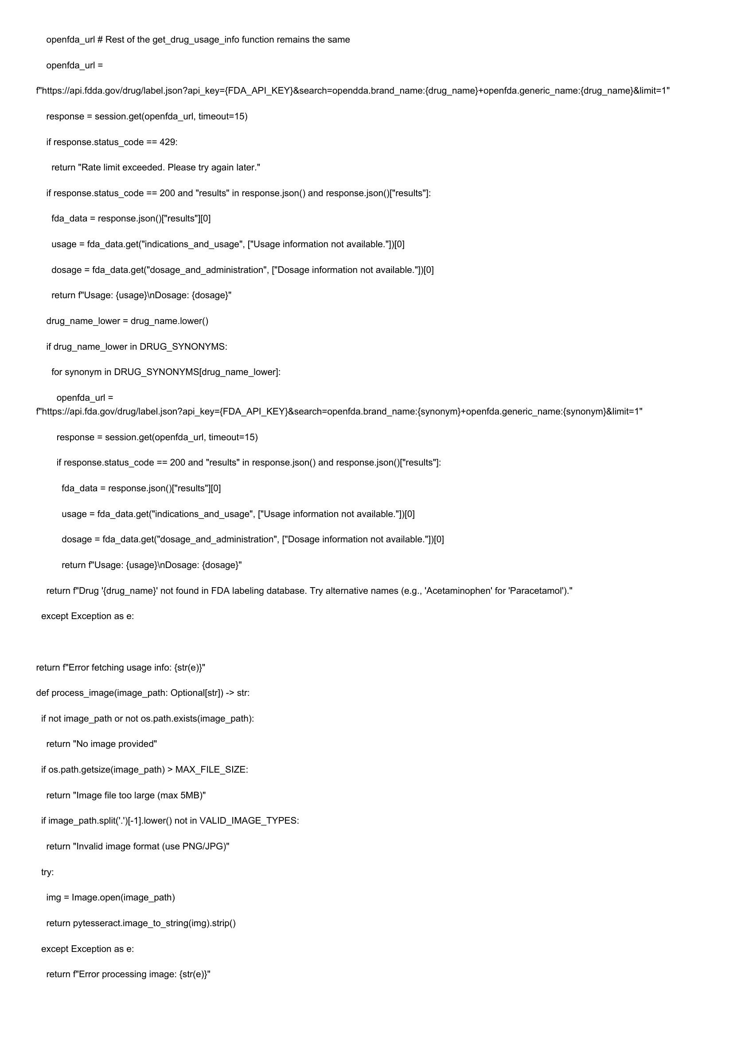

openfda_url # Rest of the get_drug_usage_info function remains the same  
  
openfda_url =  
  
f'https://api.fdda.gov/drug/label.json?api_key={FDA_API_KEY}&search=opendda.brand_name:{drug_name}topenfda.generic_name:{drug_name}&limit=1"  
  
response = session.get(openfda_url, timeout=15)  
  
if response.status_code == 429:  
  
return "Rate limit exceeded. Please try again later."  
  
if response.status_code == 200 and "results" in response.json() and response.json()["results"]:  
  
fda_data = response.json()["results"][0]  
  
usage = fda_data.get("indications_and_usage", ["Usage information not available."])[0]  
  
dosage = fda_data.get("dosage_and_administration", ["Dosage information not available."])[0]  
  
return f"Usage: {usage}\nDosage: {dosage}"  
  
drug_name_lower = drug_name.lower()  
  
if drug_name_lower in DRUG_SYNONYMS:  
  
for synonym in DRUG_SYNONYMS{[drug_name_lower]:  
  
openfda_url =  
f'https://api.fda.gov/drug/label.json?api_key={FDA_API_KEY}&search=openfda.brand_name:{synonym}+openfda.generic_name:{synonym}&limit=1"  
  
response = session.get(openfda_url, timeout=15)  
  
if response.status_code == 200 and "results" in response.json() and response.json()["results"]:  
  
fda_data = response.json()["results"][0]  
  
usage = fda_data.get("indications_and_usage", ["Usage information not available."])[0]  
  
dosage = fda_data.get("dosage_and_administration", ["Dosage information not available."])[0]  
  
return f"Usage: {usage}\nDosage: {dosage}"  
  
return f"Drug '{drug_name}' not found in FDA labeling database. Try alternative names (e.g., ‘Acetaminophen’ for 'Paracetamol')."  
  
except Exception as e:  
  
return f"Error fetching usage info: {str(e)}"  
  
def process_image(image_path: Optional[str]) -> str:  
  
if not image_path or not os.path.exists(image_path):  
  
return "No image provided"  
  
if os.path.getsize(image_path) > MAX_FILE_SIZE:  
  
return "Image file too large (max 5MB)"  
  
if image_path.split(’.')[-1].lower() not in VALID_IMAGE_TYPES:  
  
return "Invalid image format (use PNG/JPG)"  
  
try:  
  
img = Image.open(image_path)  
  
return pytesseract.image_to_string(img).strip()  
  
except Exception as e:  
  
return f"Error processing image: {str(e)}"

# Page 13

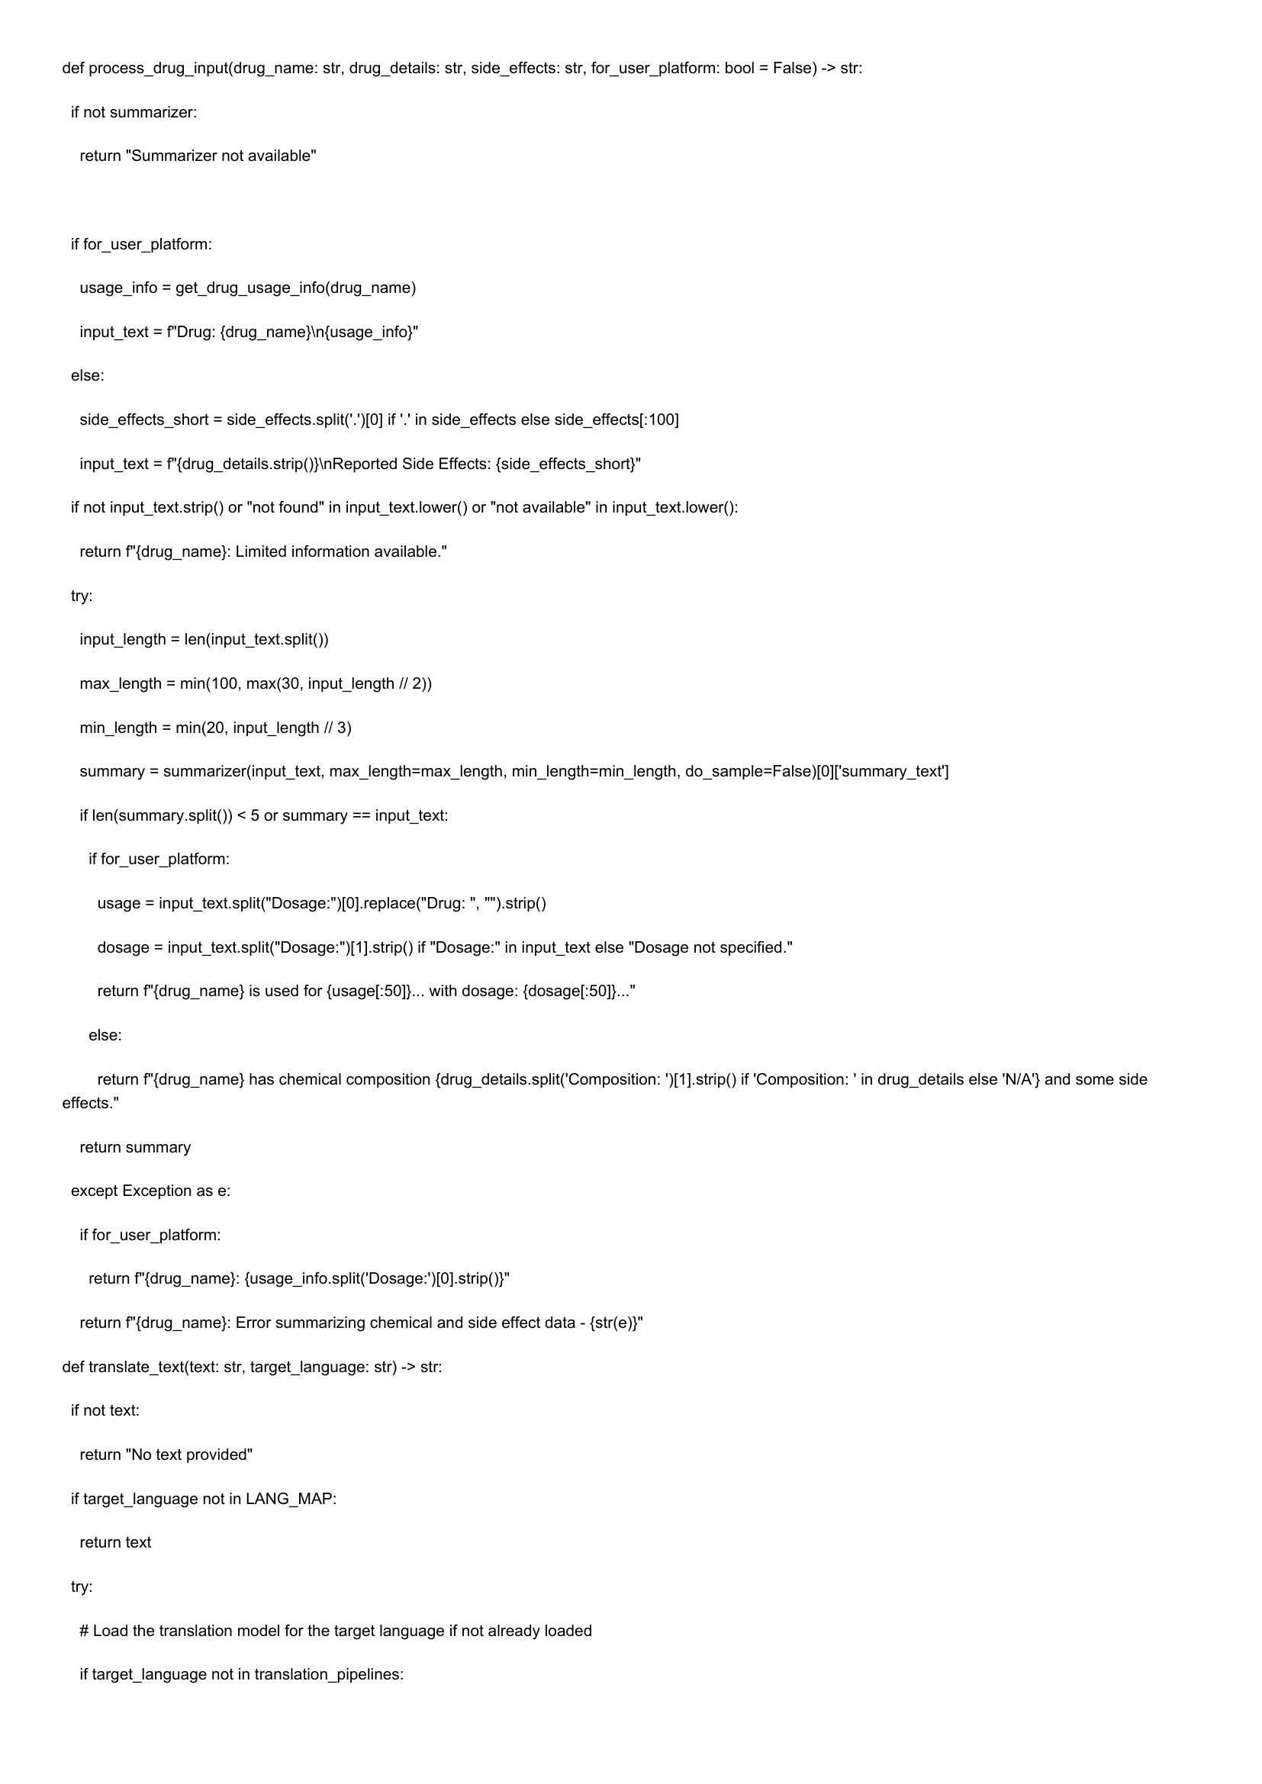

def process_drug_input(drug_name: str, drug_details: str, side_effects: str, for_user_platform: bool = False) -> str:  
if not summarizer:  
  
return "Summarizer not available"  
  
if for_user_platform:  
  
usage_info = get_drug_usage_info(drug_name)  
  
input_text = f"Drug: {drug_name}\n{usage_info}"  
  
else:  
  
side_effects_short = side_effects.split('.')[0] if '.' in side_effects else side_effects[:100]  
  
input_text = f"{drug_details.strip()}\nReported Side Effects: {side_effects_short}"  
  
if not input_text.strip() or "not found" in input_text.lower() or "not available" in input_text.lower():  
  
return f"{drug_name}: Limited information available."  
  
try:  
  
input_length = len(input_text.split())  
  
max_length = min(100, max(30, input_length // 2))  
  
min_length = min(20, input_length // 3)  
  
summary = summarizer(input_text, max_length=max_length, min_length=min_length, do_sample=False)[0]['summary_text']  
  
if len(summary.split()) < 5 or summary == input_text:  
  
if for_user_platform:  
  
usage = input_text.split("Dosage:")[0].replace("Drug:  
  
").strip()  
dosage = input_text.split("Dosage:")[1].strip() if "Dosage:" in input_text else "Dosage not specified."  
return f"{drug_name} is used for {usage[:50]}... with dosage: {dosage[:50]}..."  
  
else:  
  
return f"{drug_name} has chemical composition {drug_details.split('Composition: ')[1].strip() if ‘Composition: ' in drug_details else 'N/A'} and some side  
effects."  
  
return summary  
  
except Exception as e:  
  
if for_user_platform:  
  
return f"{drug_name}: {usage_info.split(‘Dosage:’)[0].strip()}"  
  
return f"{drug_name}: Error summarizing chemical and side effect data - {str(e)}"  
  
def translate_text(text: str, target_language: str) -> str:  
  
if not text:  
  
return "No text provided"  
  
if target_language not in LANG_MAP:  
  
return text  
  
try:  
  
# Load the translation model for the target language if not already loaded  
  
if target_language not in translation_pipelines:

# Page 14

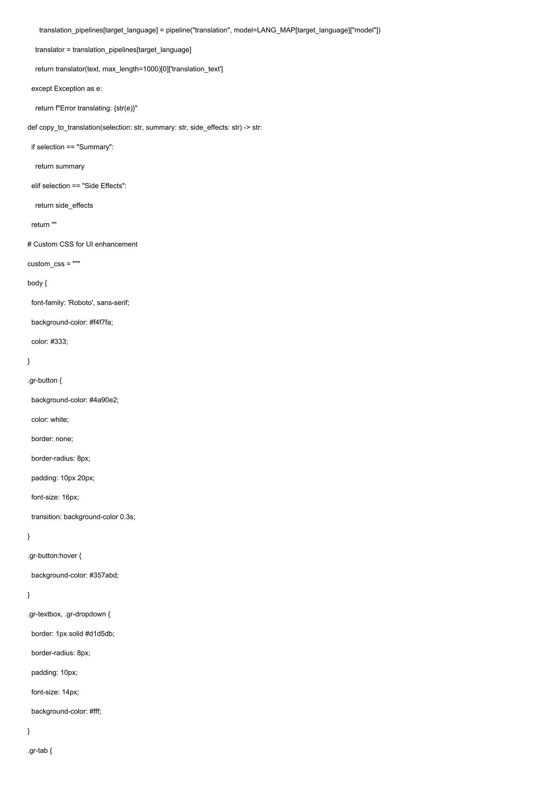

translation_pipelines[target_language] = pipeline("translation", model=LANG_MAP{target_language]["model"])  
translator = translation_pipelines[target_language]  
return translator(text, max_length=1000)[0]['translation_text']  
except Exception as e:  
return f"Error translating: {str(e)}"  
def copy_to_translation(selection: str, summary: str, side_effects: str) -> str:  
if selection == "Summary":  
return summary  
elif selection == "Side Effects":  
return side_effects  
return"  
# Custom CSS for Ul enhancement  
custom_css = """  
body {  
font-family: 'Roboto’, sans-serif;  
background-color: #f4f7fa;  
color: #333;  
}  
.gr-button {  
background-color: #4a90e2;  
color: white;  
border: none;  
border-radius: 8px;  
padding: 10px 20px;  
font-size: 16px;  
transition: background-color 0.3s;  
  
}  
  
.gr-button:hover {  
background-color: #357abd;  
  
}  
  
.gr-textbox, .gr-dropdown {  
border: 1px solid #d1d5db;  
border-radius: 8px;  
padding: 10px;  
font-size: 14px;  
  
background-color: #fff;  
  
.gr-tab {

# Page 15

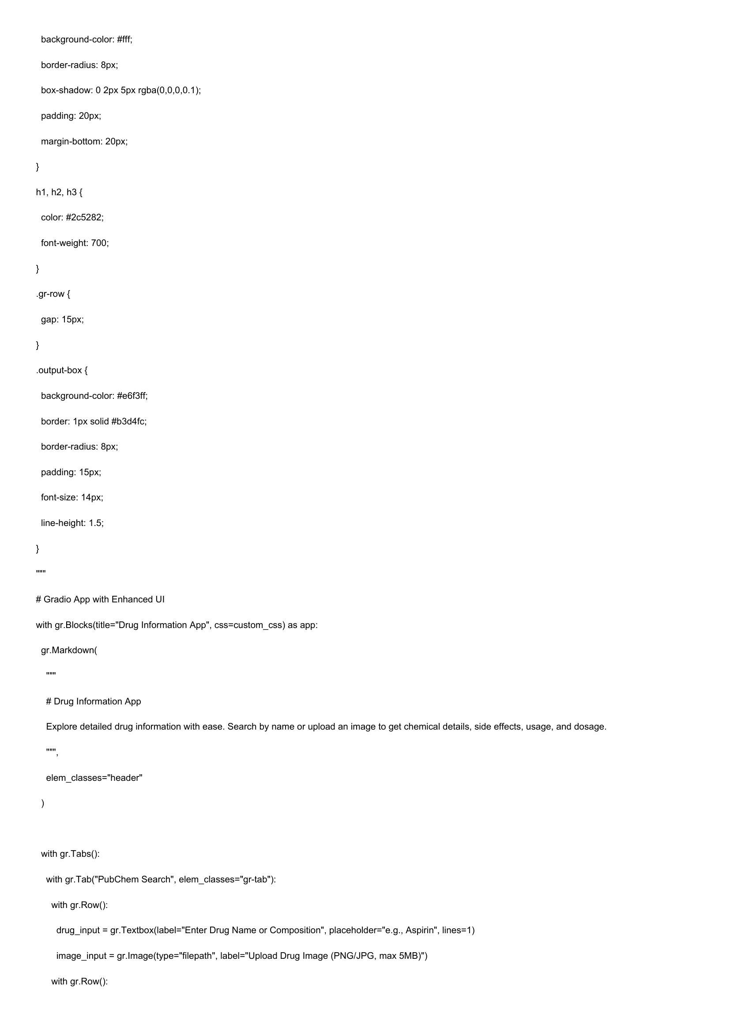

background-color: #fff;  
  
border-radius: 8px;  
  
box-shadow: 0 2px 5px rgba(0,0,0,0.1);  
padding: 20px;  
  
margin-bottom: 20px;  
  
h1, h2, h3 {  
color: #2c5282;  
font-weight: 700;  
  
}  
  
.gr-row {  
gap: 15px;  
  
}  
  
.output-box {  
background-color: #e6f3ff;  
border: 1px solid #b3d4fc;  
border-radius: 8px;  
padding: 15px;  
font-size: 14px;  
  
line-height: 1.5;  
  
# Gradio App with Enhanced UI  
  
with gr.Blocks(title="Drug Information App", css=custom_css) as app:  
  
gr.Markdown(  
  
# Drug Information App  
  
Explore detailed drug information with ease. Search by name or upload an image to get chemical details, side effects, usage, and dosage.  
  
elem_classes="header"  
  
with gr.Tabs():  
with gr.Tab("PubChem Search", elem_classes="gr-tab"):  
with gr.Row():  
drug_input = gr.Textbox(label="Enter Drug Name or Composition", placeholder="e.g., Aspirin", lines=1)  
  
image_input = gr.Image(type="filepath", label="Upload Drug Image (PNG/JPG, max 5MB)")  
  
with gr.Row():

# Page 16

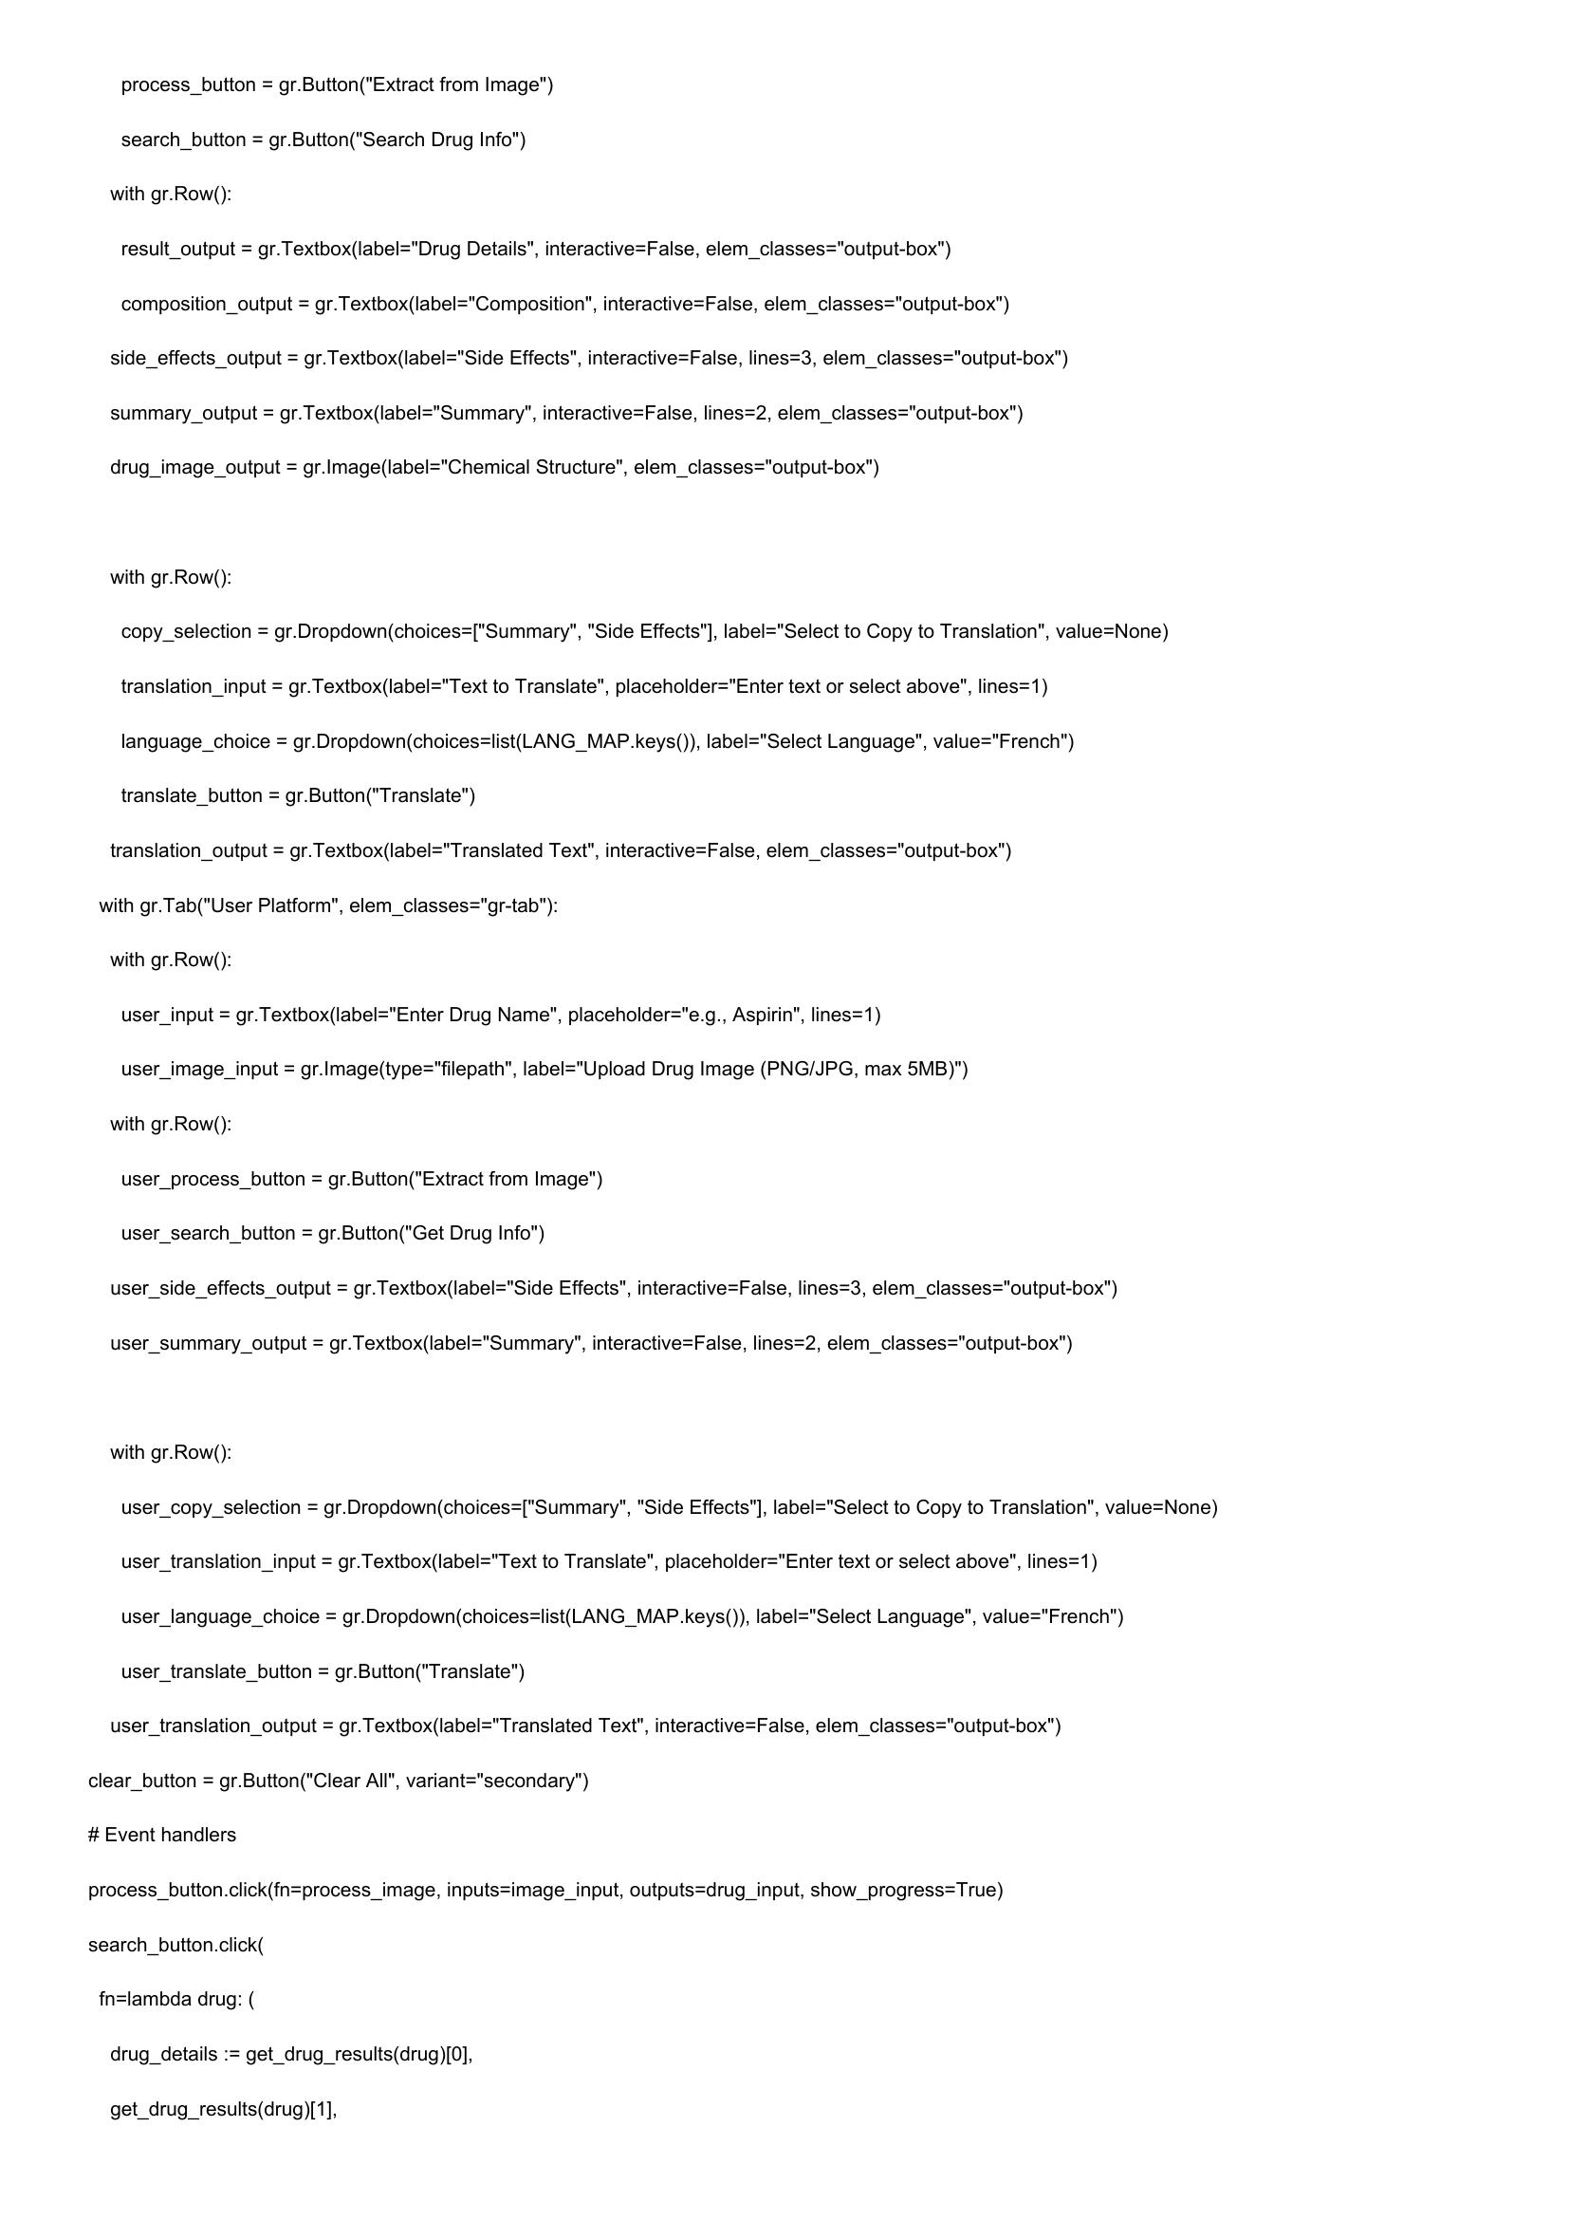

process_button = gr.Button("Extract from Image")  
  
search_button = gr.Button("Search Drug Info")  
with gr.Row():  
  
result_output = gr.Textbox(label="Drug Details", interactive=False, elem_classes="output-box")  
  
composition_output = gr.Textbox(label="Composition", interactive=False, elem_classes="output-box")  
side_effects_output = gr.Textbox(label="Side Effects", interactive=False, lines=3, elem_classes="output-box")  
summary_output = gr.Textbox(label="Summary", interactive=False, lines=2, elem_classes="output-box")  
  
drug_image_output = gr.Image(label="Chemical Structure", elem_classes="output-box")  
  
with gr.Row():  
copy_selection = gr.Dropdown(choices=["Summary", "Side Effects"], label="Select to Copy to Translation", value=None)  
translation_input = gr.Textbox(label="Text to Translate", placeholder="Enter text or select above", lines=1)  
language_choice = gr.Dropdown(choices=list(LANG_MAP.keys()), label="Select Language", value="French")  
translate_button = gr.Button("Translate")  
  
translation_output = gr. Textbox(label="Translated Text", interactive=False, elem_classes="output-box")  
  
with gr.Tab("User Platform", elem_classes="gr-tab"):  
  
with gr.Row():  
user_input = gr.Textbox(label="Enter Drug Name", placeholder="e.g., Aspirin", lines=1)  
user_image_input = gr.Image(type="filepath", label="Upload Drug Image (PNG/JPG, max 5MB)")  
  
with gr.Row():  
user_process_button = gr.Button("Extract from Image")  
user_search_button = gr.Button("Get Drug Info")  
  
user_side_effects_output = gr. Textbox(label='  
  
ide Effects", interactive=False, lines=3, elem_classes="output-box")  
  
user_summary_output = gr.Textbox(label="Summary", interactive=False, lines=2, elem_classes="output-box")  
  
with gr.Row():  
user_copy_selection = gr.Dropdown(choices=["Summary", "Side Effects"], label="Select to Copy to Translation", value=None)  
user_translation_input = gr.Textbox(label="Text to Translate", placeholder="Enter text or select above", lines=1)  
user_language_choice = gr.Dropdown(choices=list(LANG_MAP.keys()), label="Select Language", value="French")  
user_translate_button = gr.Button("Translate")  
user_translation_output = gr. Textbox(label="Translated Text", interactive=False, elem_classes="output-box")  
clear_button = gr.Button("Clear All", variant="secondary")  
# Event handlers  
process_button.click(fn=process_image, inputs=image_input, outputs=drug_input, show_progress=True)  
search_button.click(  
fn=lambda drug: (  
drug_details := get_drug_results(drug)[0],  
  
get_drug_results(drug)[1],

# Page 17

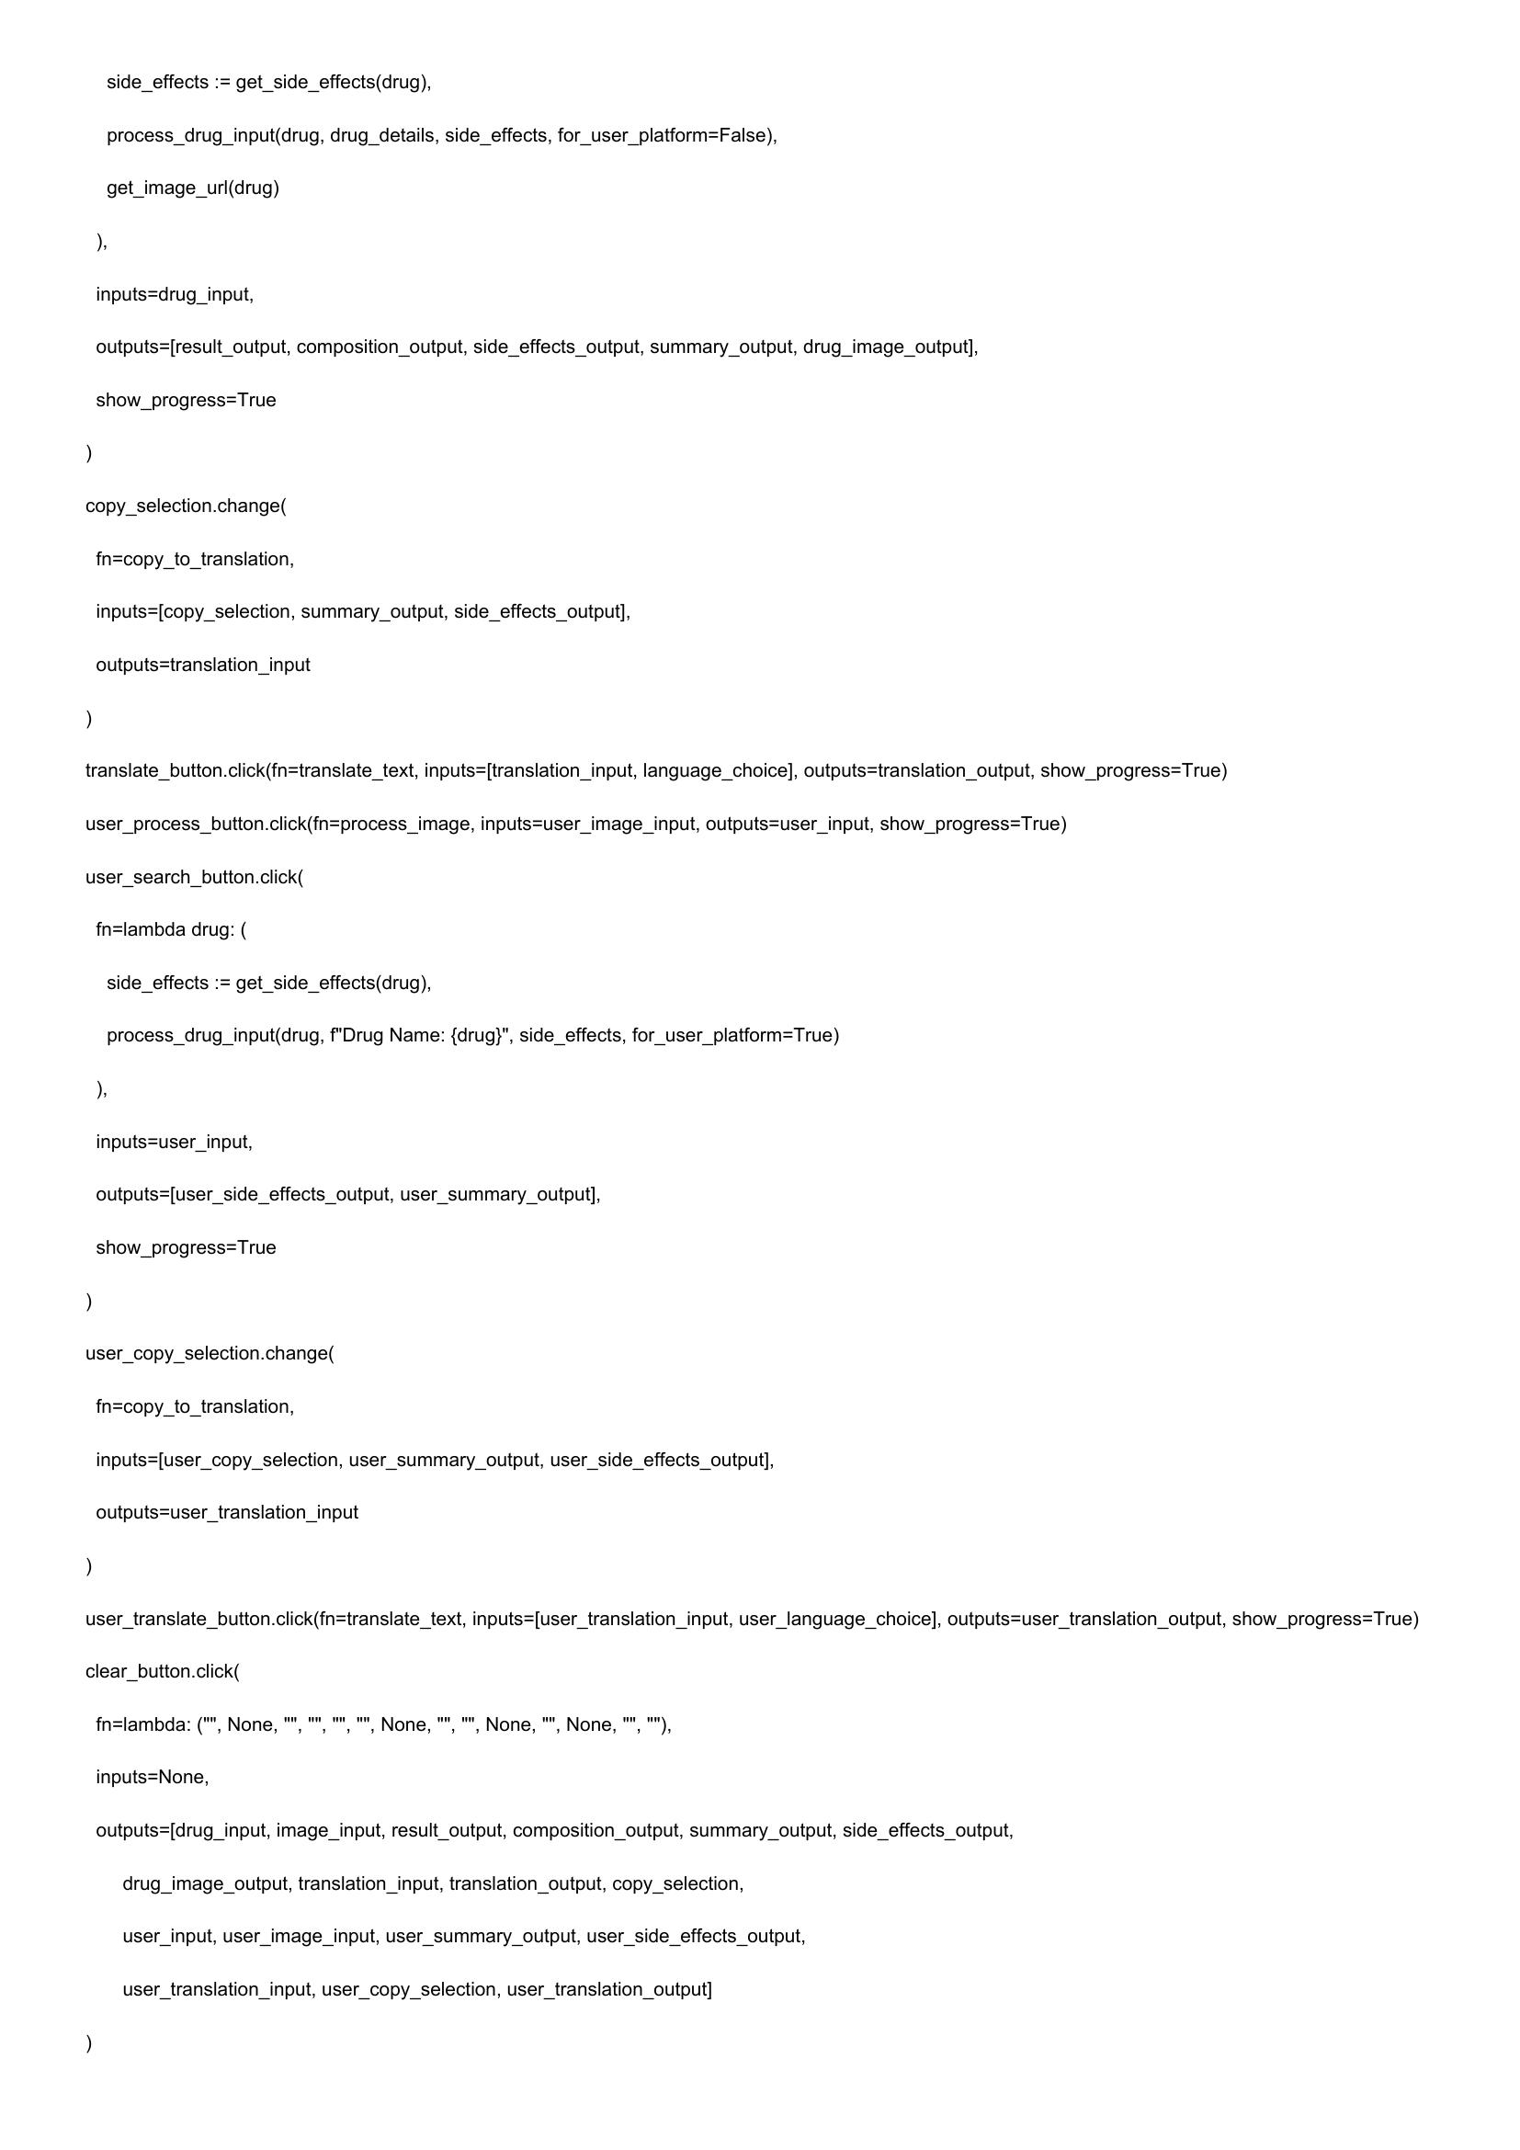

side_effects := get_side_effects(drug),  
process_drug_input(drug, drug_details, side_effects, for_user_platform=False),  
get_image_url(drug)  
)  
inputs=drug_input,  
outputs=[result_output, composition_output, side_effects_output, summary_output, drug_image_output],  
  
show_progress=True  
  
copy_selection.change(  
fn=copy_to_translation,  
inputs=[copy_selection, summary_output, side_effects_output],  
  
outputs=translation_input  
  
translate_button.click(fn=translate_text, inputs=[translation_input, language_choice], outputs=translation_output, show_progress=True)  
user_process_button.click(fn=process_image, inputs=user_image_input, outputs=user_input, show_progress=True)  
user_search_button.click(  
fn=lambda drug: (  
side_effects := get_side_effects(drug),  
process_drug_input(drug, f'Drug Name: {drug}", side_effects, for_user_platform=True)  
)  
inputs=user_input,  
outputs=[user_side_effects_output, user_summary_output],  
  
show_progress=True  
  
user_copy_selection.change(  
fn=copy_to_translation,  
inputs=[user_copy_selection, user_summary_output, user_side_effects_output],  
  
outputs=user_translation_input  
  
user_translate_button.click(fn=translate_text, inputs=[user_translation_input, user_language_choice], outputs=user_translation_output, show_progress=True)  
  
clear_button.click(  
  
"None, None, "", None.  
  
fn=lambda:  
  
inputs=None,  
  
outputs=[drug_input, image_input, result_output, composition_output, summary_output, side_effects_output,  
drug_image_output, translation_input, translation_output, copy_selection,  
user_input, user_image_input, user_summary_output, user_side_effects_output,  
  
user_translation_input, user_copy_selection, user_translation_output]

# Page 18

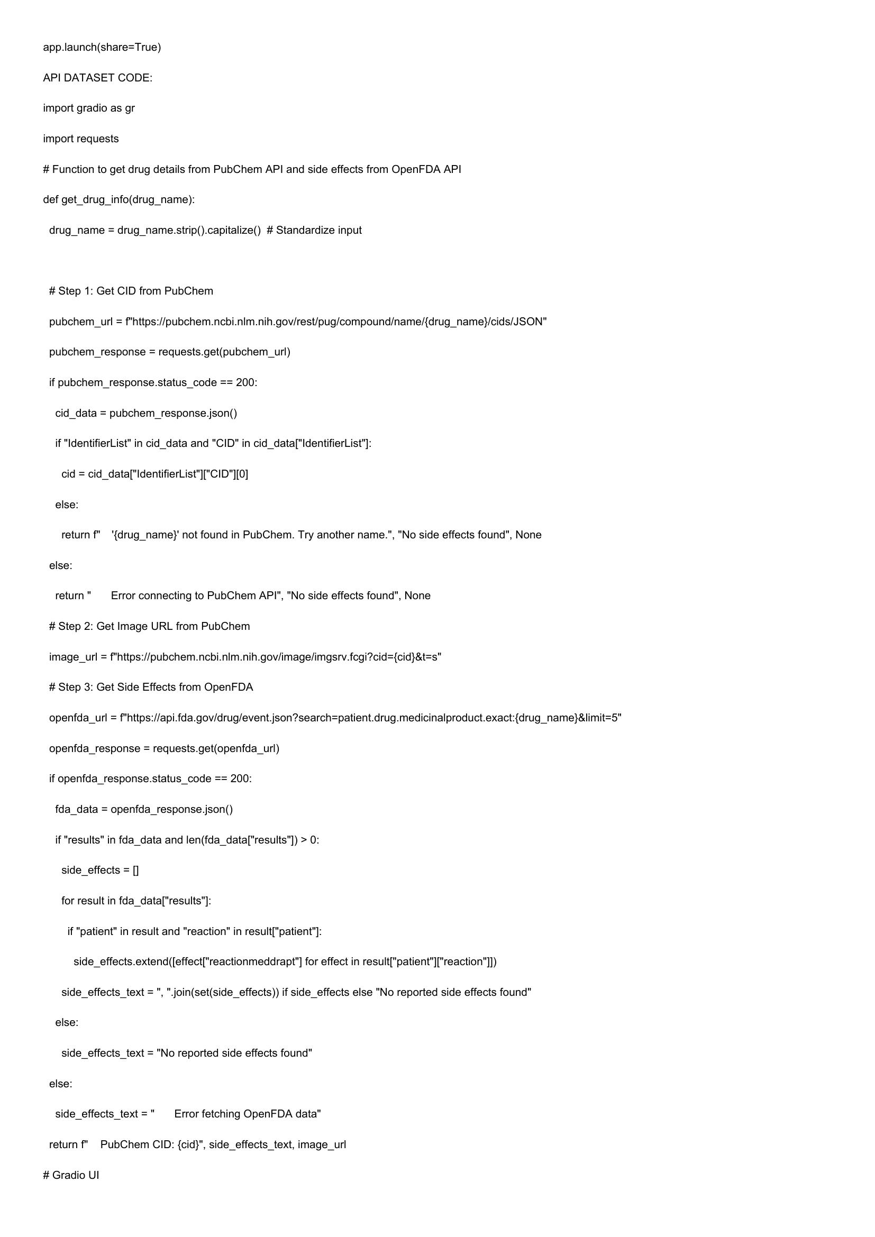

app.launch(share=True)  
  
API DATASET CODE:  
  
import gradio as gr  
  
import requests  
  
# Function to get drug details from PubChem API and side effects from OpenFDA API  
def get_drug_info(drug_name):  
  
drug_name = drug_name.strip().capitalize() # Standardize input  
  
# Step 1: Get CID from PubChem  
pubchem_url = f"https://pubchem.ncbi.nlm.nih.gov/rest/pug/compound/name/{drug_name}/cids/JSON"  
pubchem_response = requests.get(pubchem_url)  
  
if pubchem_response.status_code == 200:  
  
cid_data = pubchem_response.json()  
if "IdentifierList" in cid_data and "CID" in cid_data["IdentifierList"]:  
cid = cid_dataf"IdentifierList"]["CID"][0]  
else:  
return f" '{drug_name}' not found in PubChem. Try another name.", "No side effects found", None  
else:  
return " Error connecting to PubChem API", "No side effects found", None  
# Step 2: Get Image URL from PubChem  
image_url = f"https://pubchem.ncbi.nlm.nih.gov/image/imgsrv.fcgi?cid={cid}&t=s"  
# Step 3: Get Side Effects from OpenFDA  
openfda_url = f"https://api.fda.gov/drug/event.json?search=patient.drug.medicinalproduct.exact:{drug_name}&limit=5"  
openfda_response = requests.get(openfda_url)  
if openfda_response.status_code == 200:  
fda_data = openfda_response.json()  
if "results" in fda_data and len(fda_data["results"]) > 0:  
side_effects = []  
for result in fda_data["results"]:  
if "patient" in result and "reaction" in result["patient"]:  
side_effects.extend([effect["reactionmeddrapt"] for effect in result["patient"]["reaction"])  
side_effects_text =", "join(set(side_effects)) if side_effects else "No reported side effects found"  
else:  
side_effects_text = "No reported side effects found"  
else:  
side_effects_text =" Error fetching OpenFDA data"  
return f" PubChem CID: {cid}", side_effects_text, image_url  
  
# Gradio UI

# Page 19

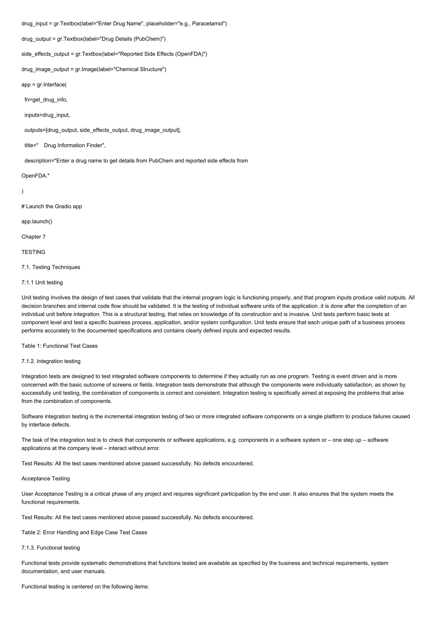

drug_input = gr. Textbox(label="Enter Drug Name", placeholder="e.g., Paracetamol")  
drug_output = gr.Textbox(label="Drug Details (PubChem)")  
side_effects_output = gr. Textbox(label="Reported Side Effects (OpenFDA)")  
drug_image_output = gr.Image(label="Chemical Structure")  
app = gr.Interface(  
  
fn=get_drug_info,  
  
inputs=drug_input,  
  
outputs=[drug_output, side_effects_output, drug_image_output],  
  
title=" Drug Information Finder",  
  
description="Enter a drug name to get details from PubChem and reported side effects from  
  
OpenFDA."  
  
# Launch the Gradio app  
app.launch()  
  
Chapter 7  
  
TESTING  
  
7.1. Testing Techniques  
7.1.1 Unit testing  
  
Unit testing involves the design of test cases that validate that the internal program logic is functioning properly, and that program inputs produce valid outputs. All  
decision branches and internal code flow should be validated. It is the testing of individual software units of the application .it is done after the completion of an  
individual unit before integration. This is a structural testing, that relies on knowledge of its construction and is invasive. Unit tests perform basic tests at  
component level and test a specific business process, application, and/or system configuration. Unit tests ensure that each unique path of a business process  
performs accurately to the documented specifications and contains clearly defined inputs and expected results.  
  
Table 1: Functional Test Cases  
  
7.1.2. Integration testing  
  
Integration tests are designed to test integrated software components to determine if they actually run as one program. Testing is event driven and is more  
concerned with the basic outcome of screens or fields. Integration tests demonstrate that although the components were individually satisfaction, as shown by  
successfully unit testing, the combination of components is correct and consistent. Integration testing is specifically aimed at exposing the problems that arise  
from the combination of components.  
  
Software integration testing is the incremental integration testing of two or more integrated software components on a single platform to produce failures caused  
by interface defects.  
  
The task of the integration test is to check that components or software applications, e.g. components in a software system or — one step up — software  
applications at the company level — interact without error.  
  
Test Results: All the test cases mentioned above passed successfully. No defects encountered.  
Acceptance Testing  
  
User Acceptance Testing is a critical phase of any project and requires significant participation by the end user. It also ensures that the system meets the  
functional requirements.  
  
Test Results: All the test cases mentioned above passed successfully. No defects encountered.  
Table 2: Error Handling and Edge Case Test Cases  
7.1.3. Functional testing  
  
Functional tests provide systematic demonstrations that functions tested are available as specified by the business and technical requirements, system  
documentation, and user manuals.  
  
Functional testing is centered on the following items:

# Page 20

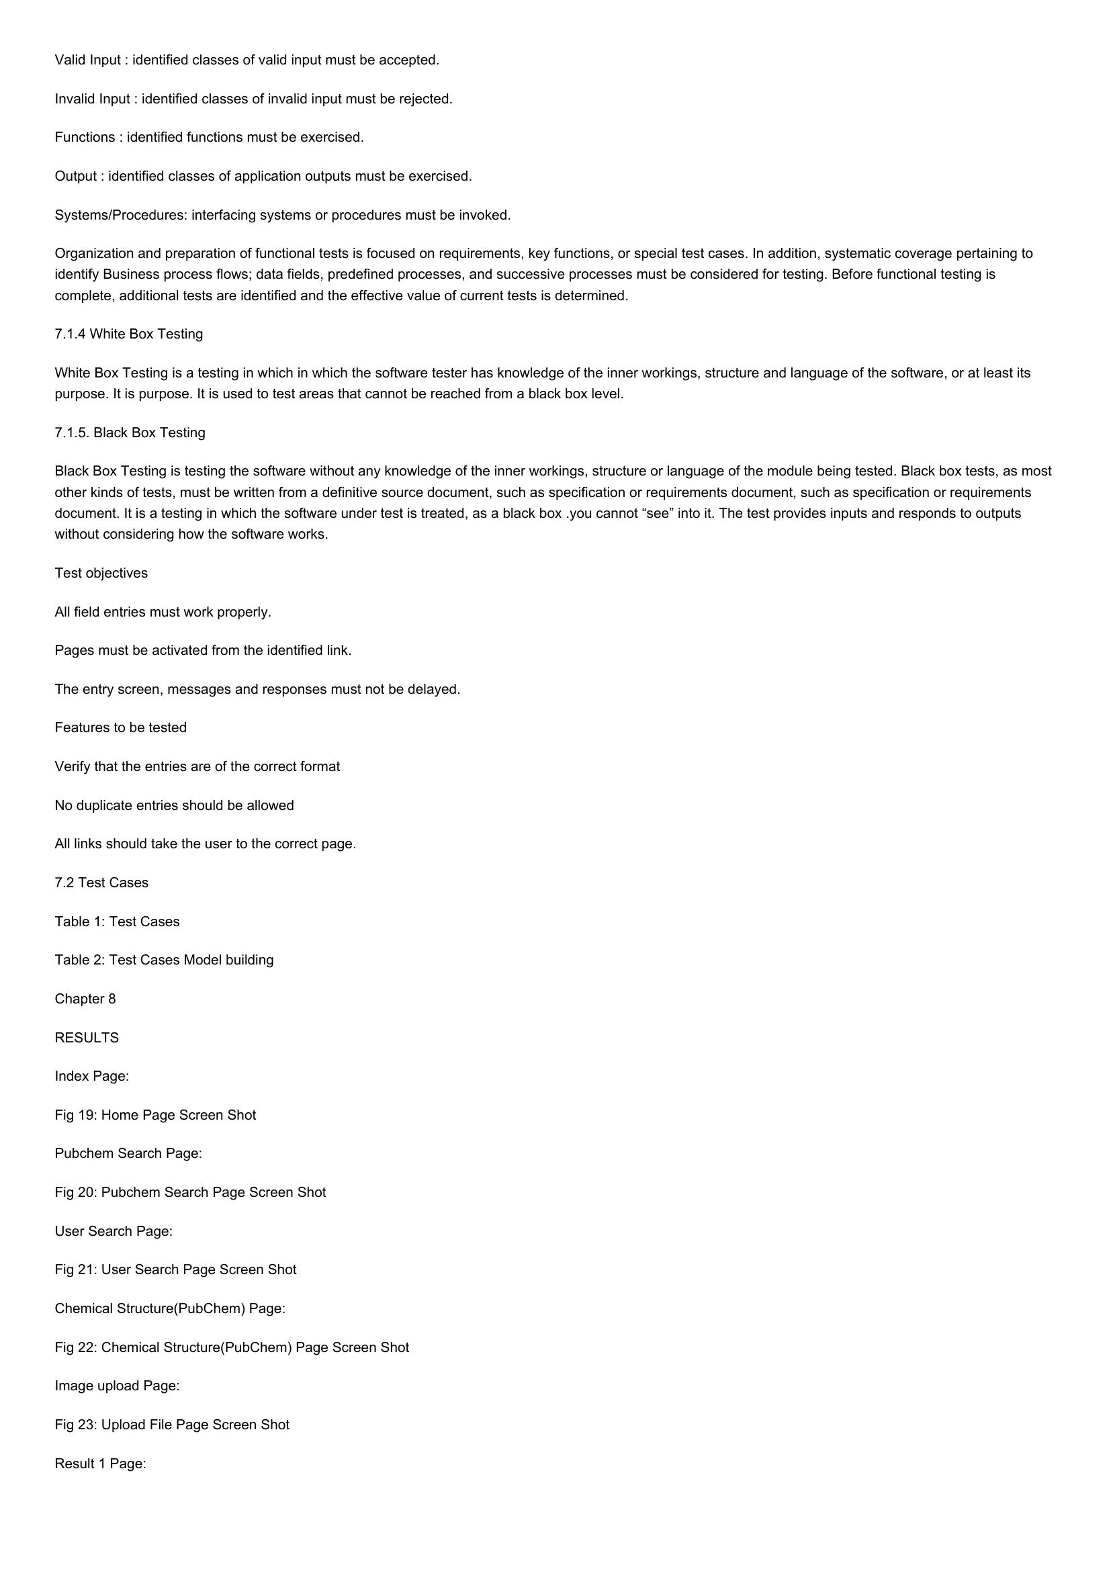

Valid Input : identified classes of valid input must be accepted.  
  
Invalid Input : identified classes of invalid input must be rejected.  
Functions : identified functions must be exercised.  
  
Output : identified classes of application outputs must be exercised.  
Systems/Procedures: interfacing systems or procedures must be invoked.  
  
Organization and preparation of functional tests is focused on requirements, key functions, or special test cases. In addition, systematic coverage pertaining to  
identify Business process flows; data fields, predefined processes, and successive processes must be considered for testing. Before functional testing is  
complete, additional tests are identified and the effective value of current tests is determined.  
  
7.1.4 White Box Testing  
  
White Box Testing is a testing in which in which the software tester has knowledge of the inner workings, structure and language of the software, or at least its  
purpose. It is purpose. It is used to test areas that cannot be reached from a black box level.  
  
7.1.5. Black Box Testing  
  
Black Box Testing is testing the software without any knowledge of the inner workings, structure or language of the module being tested. Black box tests, as most  
other kinds of tests, must be written from a definitive source document, such as specification or requirements document, such as specification or requirements  
document. It is a testing in which the software under test is treated, as a black box .you cannot “see” into it. The test provides inputs and responds to outputs  
without considering how the software works.  
  
Test objectives  
  
All field entries must work properly.  
  
Pages must be activated from the identified link.  
  
The entry screen, messages and responses must not be delayed.  
  
Features to be tested  
  
Verify that the entries are of the correct format  
  
No duplicate entries should be allowed  
  
All links should take the user to the correct page.  
  
7.2 Test Cases  
  
Table 1: Test Cases  
  
Table 2: Test Cases Model building  
  
Chapter 8  
  
RESULTS  
  
Index Page:  
  
Fig 19: Home Page Screen Shot  
  
Pubchem Search Page:  
  
Fig 20: Pubchem Search Page Screen Shot  
  
User Search Page:  
  
Fig 21: User Search Page Screen Shot  
  
Chemical Structure(PubChem) Page:  
  
Fig 22: Chemical Structure(PubChem) Page Screen Shot  
  
Image upload Page:  
  
Fig 23: Upload File Page Screen Shot  
  
Result 1 Page:

# Page 21

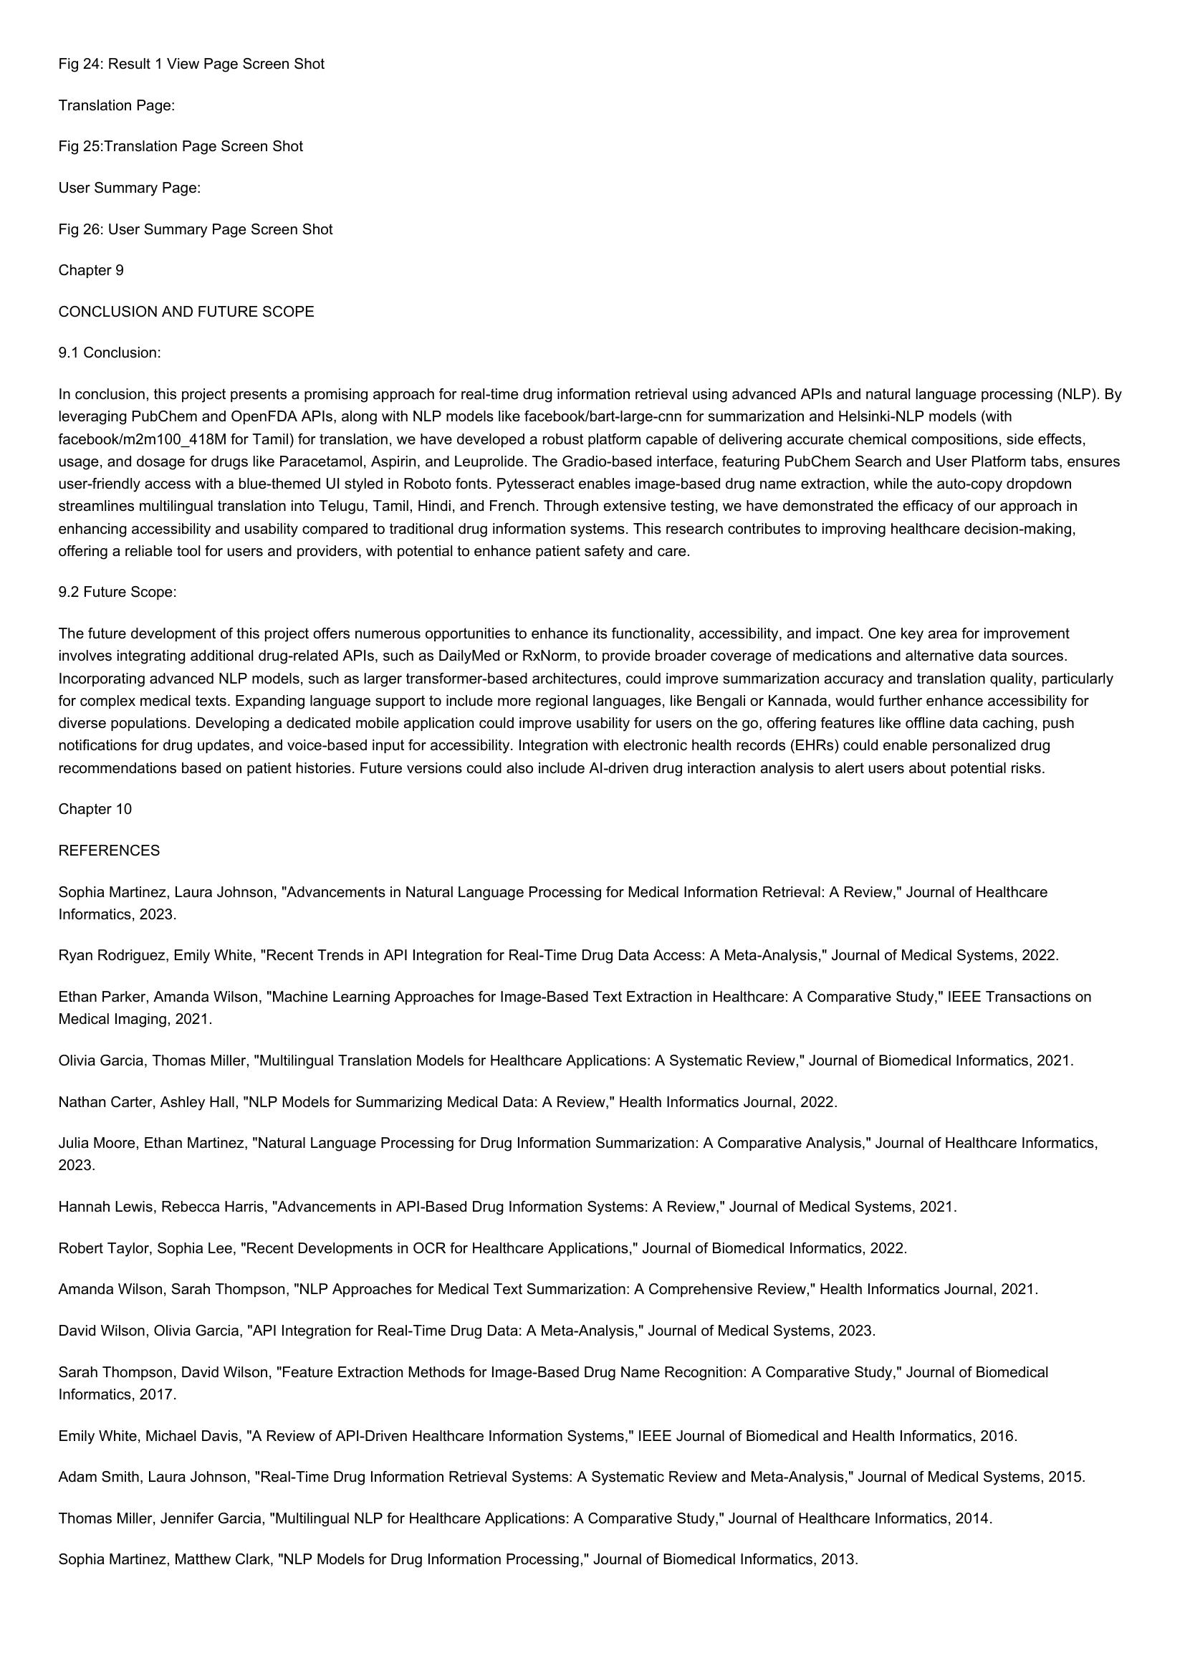

Fig 24: Result 1 View Page Screen Shot  
Translation Page:  
  
Fig 25:Translation Page Screen Shot  
User Summary Page:  
  
Fig 26: User Summary Page Screen Shot  
Chapter 9  
  
CONCLUSION AND FUTURE SCOPE  
9.1 Conclusion:  
  
In conclusion, this project presents a promising approach for real-time drug information retrieval using advanced APIs and natural language processing (NLP). By  
leveraging PubChem and OpenFDA APIs, along with NLP models like facebook/bart-large-cnn for summarization and Helsinki-NLP models (with  
facebook/m2m100_418M for Tamil) for translation, we have developed a robust platform capable of delivering accurate chemical compositions, side effects,  
usage, and dosage for drugs like Paracetamol, Aspirin, and Leuprolide. The Gradio-based interface, featuring PubChem Search and User Platform tabs, ensures  
user-friendly access with a blue-themed UI styled in Roboto fonts. Pytesseract enables image-based drug name extraction, while the auto-copy dropdown  
streamlines multilingual translation into Telugu, Tamil, Hindi, and French. Through extensive testing, we have demonstrated the efficacy of our approach in  
enhancing accessibility and usability compared to traditional drug information systems. This research contributes to improving healthcare decision-making,  
offering a reliable tool for users and providers, with potential to enhance patient safety and care.  
  
9.2 Future Scope:  
  
The future development of this project offers numerous opportunities to enhance its functionality, accessibility, and impact. One key area for improvement  
involves integrating additional drug-related APIs, such as DailyMed or RxNorm, to provide broader coverage of medications and alternative data sources.  
Incorporating advanced NLP models, such as larger transformer-based architectures, could improve summarization accuracy and translation quality, particularly  
for complex medical texts. Expanding language support to include more regional languages, like Bengali or Kannada, would further enhance accessibility for  
diverse populations. Developing a dedicated mobile application could improve usability for users on the go, offering features like offline data caching, push  
notifications for drug updates, and voice-based input for accessibility. Integration with electronic health records (EHRs) could enable personalized drug  
recommendations based on patient histories. Future versions could also include Al-driven drug interaction analysis to alert users about potential risks.  
  
Chapter 10  
REFERENCES  
  
Sophia Martinez, Laura Johnson, "Advancements in Natural Language Processing for Medical Information Retrieval: A Review," Journal of Healthcare  
Informatics, 2023.  
  
Ryan Rodriguez, Emily White, "Recent Trends in API Integration for Real-Time Drug Data Access: A Meta-Analysis," Journal of Medical Systems, 2022.  
  
Ethan Parker, Amanda Wilson, "Machine Learning Approaches for Image-Based Text Extraction in Healthcare: A Comparative Study," IEEE Transactions on  
Medical Imaging, 2021.  
  
Olivia Garcia, Thomas Miller, "Multilingual Translation Models for Healthcare Applications: A Systematic Review," Journal of Biomedical Informatics, 2021.  
Nathan Carter, Ashley Hall, "NLP Models for Summarizing Medical Data: A Review," Health Informatics Journal, 2022.  
  
Julia Moore, Ethan Martinez, "Natural Language Processing for Drug Information Summarization: A Comparative Analysis," Journal of Healthcare Informatics,  
2023.  
  
Hannah Lewis, Rebecca Harris, "Advancements in API-Based Drug Information Systems: A Review," Journal of Medical Systems, 2021.  
  
Robert Taylor, Sophia Lee, "Recent Developments in OCR for Healthcare Applications," Journal of Biomedical Informatics, 2022.  
  
Amanda Wilson, Sarah Thompson, "NLP Approaches for Medical Text Summarization: A Comprehensive Review," Health Informatics Journal, 2021.  
David Wilson, Olivia Garcia, "API Integration for Real-Time Drug Data: A Meta-Analysis," Journal of Medical Systems, 2023.  
  
Sarah Thompson, David Wilson, "Feature Extraction Methods for Image-Based Drug Name Recognition: A Comparative Study," Journal of Biomedical  
Informatics, 2017.  
  
Emily White, Michael Davis, "A Review of API-Driven Healthcare Information Systems," IEEE Journal of Biomedical and Health Informatics, 2016.  
Adam Smith, Laura Johnson, "Real-Time Drug Information Retrieval Systems: A Systematic Review and Meta-Analysis," Journal of Medical Systems, 2015.  
Thomas Miller, Jennifer Garcia, "Multilingual NLP for Healthcare Applications: A Comparative Study," Journal of Healthcare Informatics, 2014.  
  
Sophia Martinez, Matthew Clark, "NLP Models for Drug Information Processing," Journal of Biomedical Informatics, 2013.